Management Control System

Software Training Materials

Contents

1. INTRODUCTION OF MANAGEMENT CONTROL SYSTEM 4

How to Log in the MCS 5

2. Planning and Development Wing 5

3. Planning and Development Dashboard 6

4. Planning and Development Menus Overview 9

4.1: Feasibility Study(Menu) Overview 10

4.1.1: Create ( Feasibility Study) Add New Feasibility Study Input Form 10

4.1.2: Manage (Feasibility Study ) View of Feasibility Study Data 11

View single Feasibility Study Report: 12

View single Feasibility Study Report print: 13

Update Feasibility Study Data form 13

4.2: On Going Projects Overview 15

4.2.1:Create(On Going Project) Add new Construction Input Form 15

4.2.2: Manage (On Going Project) View all Construction Data 16

Update Construction data: 17

Monthly Report view: 17

Monthly Project Report upload: 18

Single Constructions data view details: 18

Add details: 19

Update details: 19

4.3: Pipeline Overview 20

4.3.1: Create (Pipeline) Add New Pipeline Input Form 20

4.3.2: Manage (Pipeline) View of Pipeline Data 21

Pipeline Data Edit 21

Pipeline data delete functionality 22

4.4: Project Progress Overview 23

4.4.1: Create (Project Progress) Add Construction of new projects & Add Details of project progress Input Form 23

4.4.2: Manage (Project Progress) View Of Project Data 24

View Single Construction Details 25

View Single Construction Details Print 25

New Project & Details of the project progress Edit functionality 26

4.4.3: Photo Gallery (Project Progress) View Photo Gallery Data 28

Edit Photo Gallery Data 29

4.5: O & M (Operations And Maintenance) Overview 31

4.5.1: Create (O & M) Add New Operations & Maintenance Input Form 31

4.5.2: Manage (O & M) View Operations & Maintenance Data 32

Update Operations & Maintenance Data 32

4.6: PPP Cell Overview 33

4.6.1: About PPP Cell(PPP Cell) View about ppp cell 34

4.6.2.1: Create<-Upcoming ppp project<-(PPP Cell) Upcoming ppp project create input from 35

4.6.2.2: Manage<-Upcoming ppp project<-(PPP Cell) View upcoming all ppp project data 36

4.6.3.1: Create-Ongoing ppp project-(PPP Cell) Ongoing ppp project create input from 38

4.6.3.2: Manage-Ongoing ppp project-(PPP Cell) View of ongoing ppp project data 39

Ongoing ppp project data Search 39

Update ongoing ppp project data input form 40

Ongoing ppp project data Delete 40

4.7: FAQ Overview 41

4.7.1: Create (FAQ) View of faq data 41

Add Faq Data input form 42

Edit FAQ data 42

Delete FAQ Data 42

4.8: Settings Overview 43

4.8.1.1: FCP(Settings) View fcp data 44

FCP Add data input form 44

View FCP single data details 45

FCP single data edit 45

fcp single data delete 45

4.8.2.1: Component Data(Settings) Add data input form 46

View component and project data: 46

Component data edit 47

Project data Update form 48

Project data delete 49

4.8.3.1: Project Data(Settings) Add project data input form 50

Project data edit 50

Project data delete 50

# 

# 1. INTRODUCTION OF MANAGEMENT CONTROL SYSTEM

……….

….

…….

…….

…….

The link for MCS is <http://192.168.3.7:3000/> which is accessible within BBA’s local network . After search will open a login page. Which is like –

## How to Log in the MCS

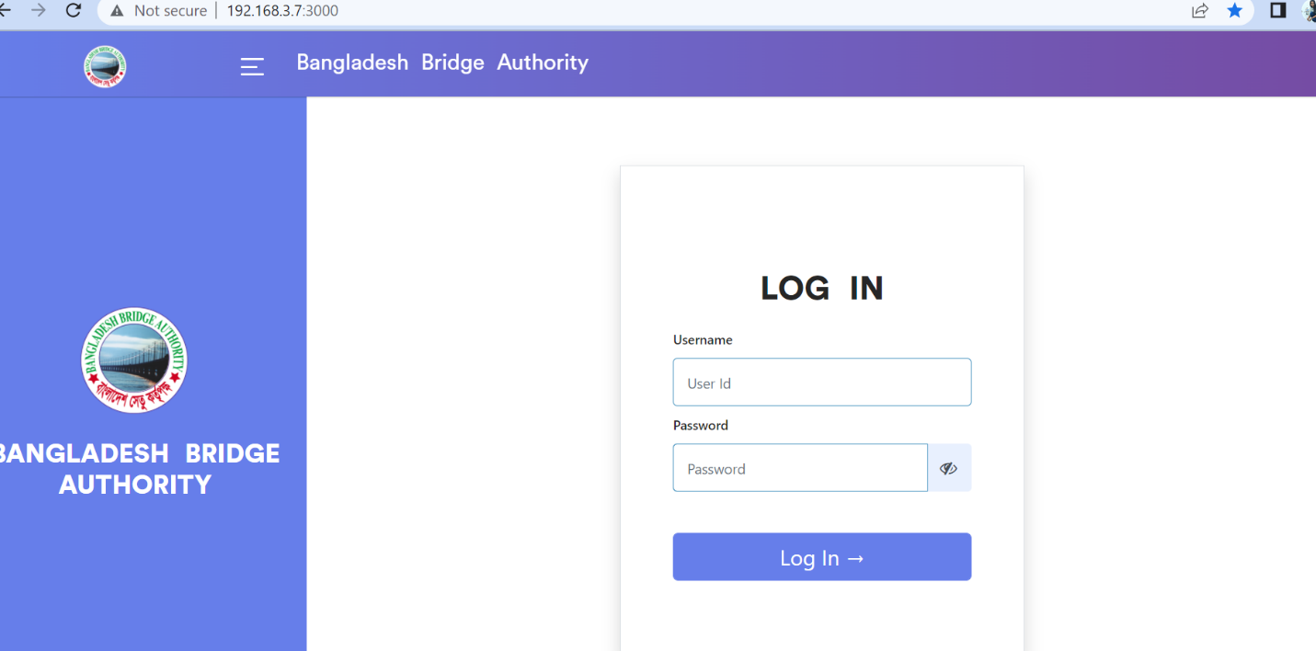

Figure 1: Log in Page

**Steps to Log in MCS**

1. User will input his Username
2. User will input his Password
3. Click Log In Button

If the username & password are correct, users will get access into the system.

# 2. Planning and Development Wing

For Planning and development module –

**Steps to Enter in Planning And Development**

1. After login will show this dashboard of MCS.

2. Click on Planning and Development.

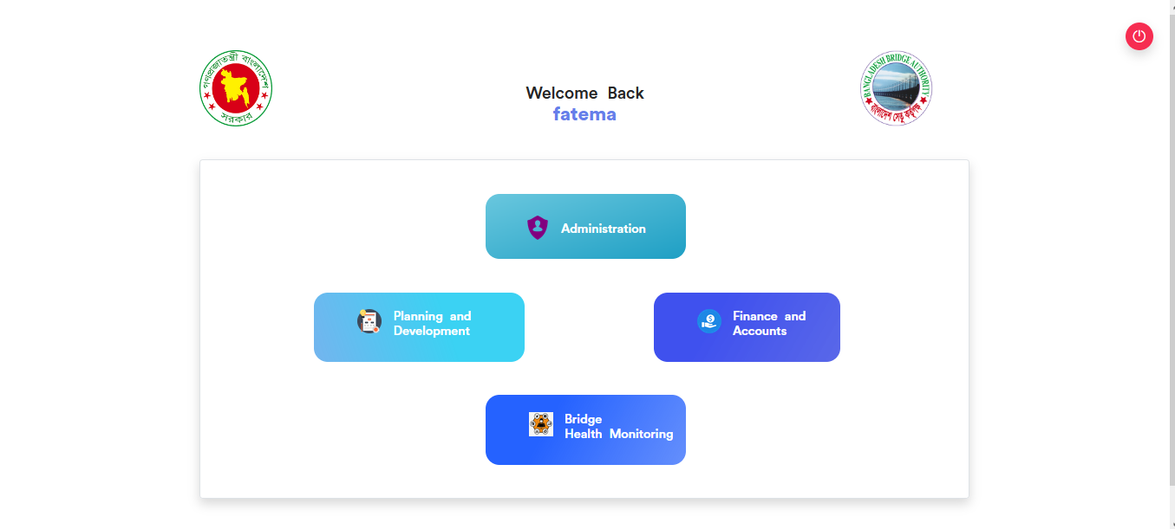

Figure 2: Dashboard of MCS

# 3. Planning and Development Dashboard

After clicking into Planning And Development then it will redirect to (P&D) dashboard with some menus.

There are three segments on the right side of the P & D Dashboard Such as **Feasibility Study** ,**On Going Projects** and **Operations and Maintenance**.

**Feasibility Study**: To generate various report from the feasibility study just do the following step .

1.Click on the relevant link ( Inspection ,Lap Rap, Draft ,Interim ,Final) report to generate the relative report.

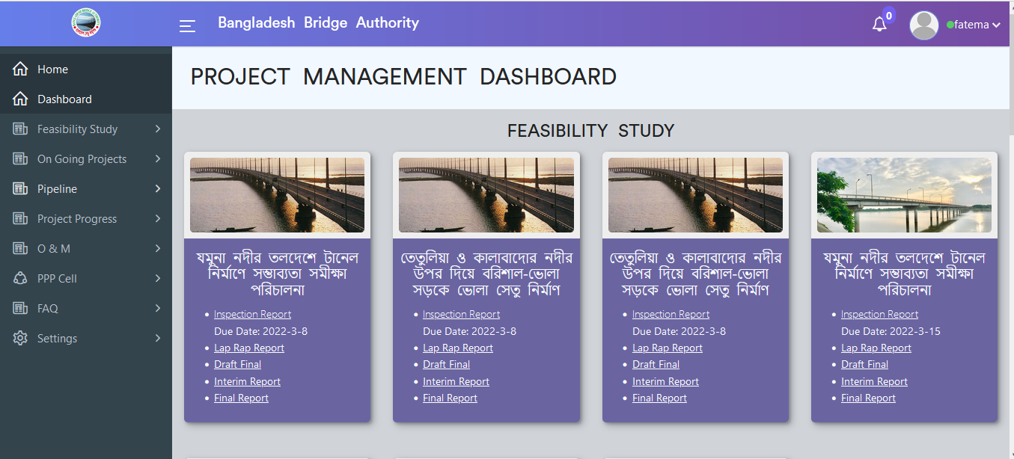

Figure 3.1: Dashboard of P&D (feasibility study)

**On-Going project :**

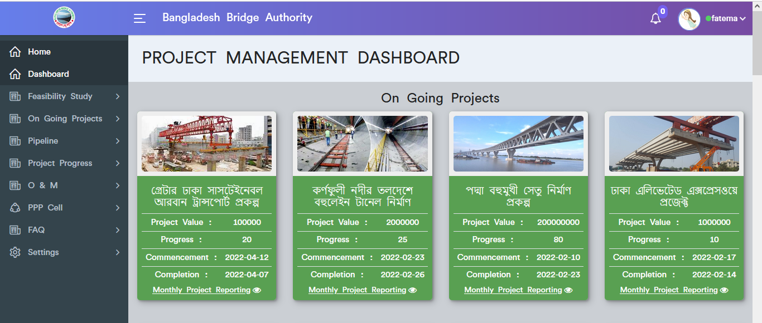

Figure 3.2: Dashboard of P&D (On Going Projects)

To see the Month wise Project Report ,just click on the monthly project reporting button then it will redirect to monthly project report page.

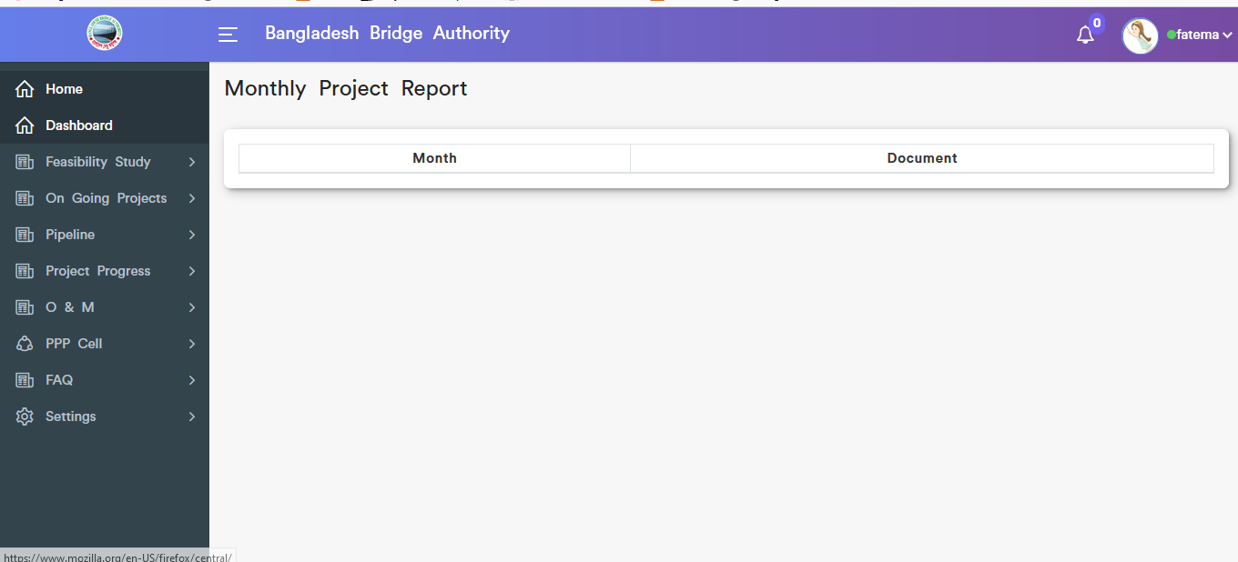

Figure 3.2.1: On going monthly project report

**Operation & Maintenance :**

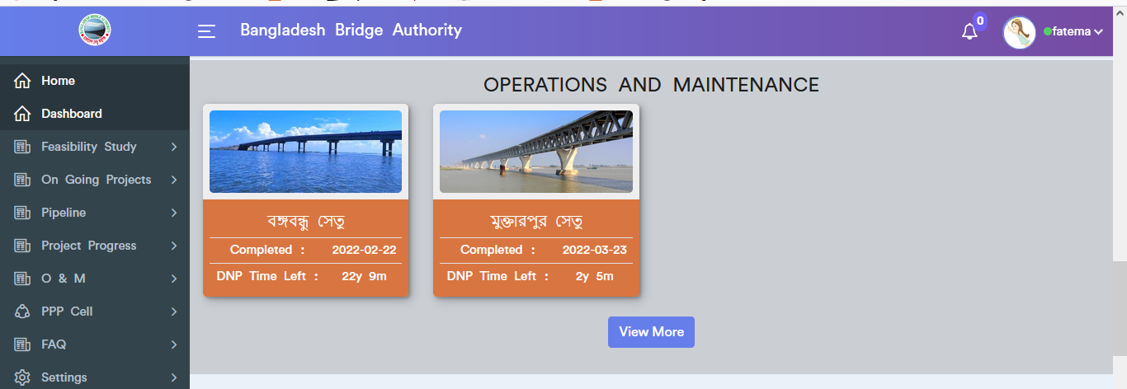

Figure 3.3: Dashboard of P&D (Operation & maintenance)

To see the Operations & Maintenance more data click on the view more button after that it will redirect to operations & maintenance data table which is looks like below scenario.

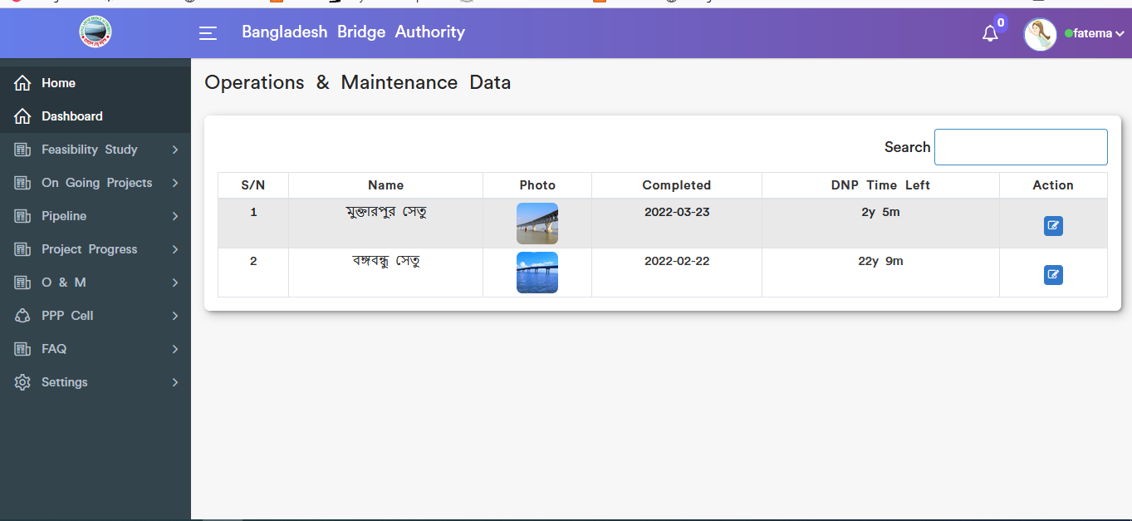

Figure 3.3.1: Dashboard of P&D (Operation & maintenance) More data

# Planning and Development Menus Overview

## 4.1: Feasibility Study(Menu) Overview

**Overview of Feasibility Study**

Click on the Feasibility Study after that there will appear two sub-menus and they are Create and Manage Feasibility Study .

### 4.1.1: Create ( Feasibility Study) Add New Feasibility Study Input Form

.

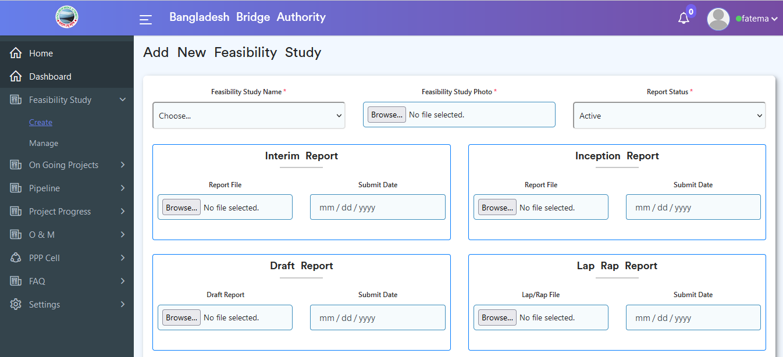

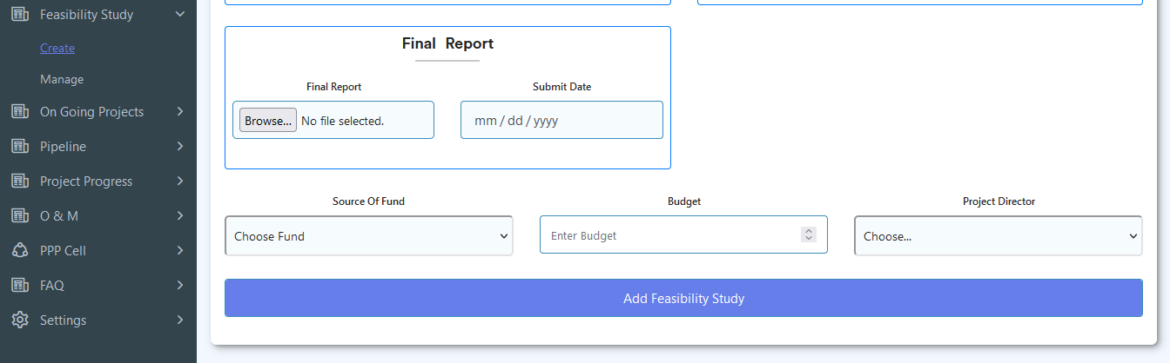

Figure 4.1.1: add new feasibility input form

### 4.1.2: Manage (Feasibility Study ) View of Feasibility Study Data

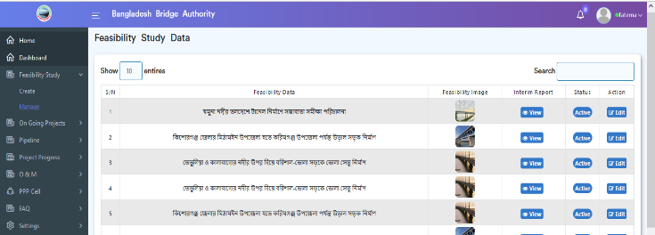.

Figure 4.1.2: view feasibility study data

### View single Feasibility Study Report:

If click on the view button then it will redirect to single feasibility view report page.

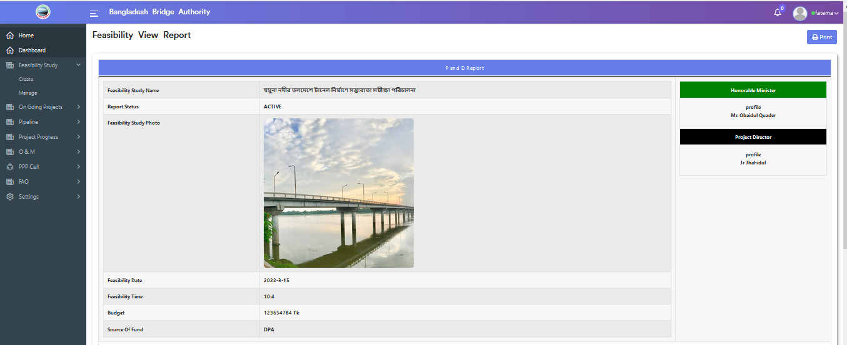

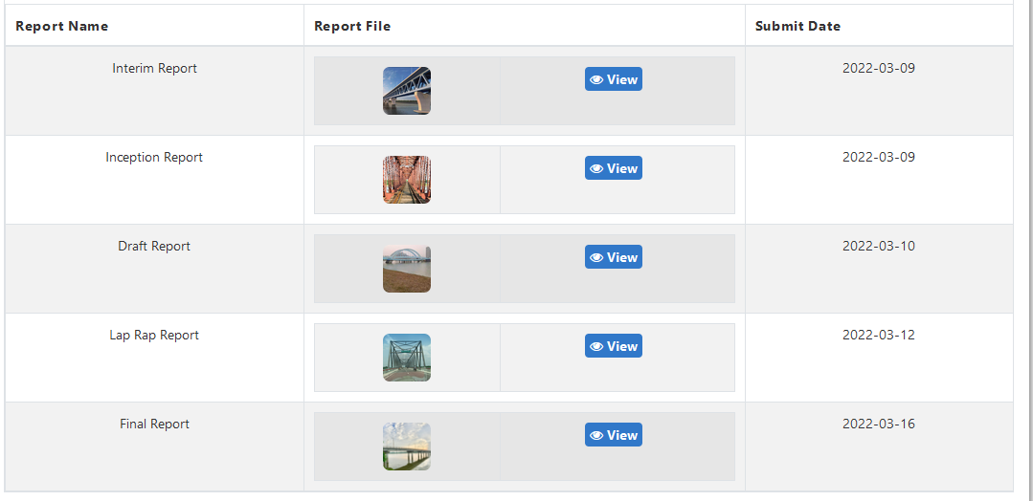

Figure 4.1.2.1: view single feasibility study Report

### View single Feasibility Study Report print:

Click on the print button after that printing functionality will appear which is looks like below scenario.

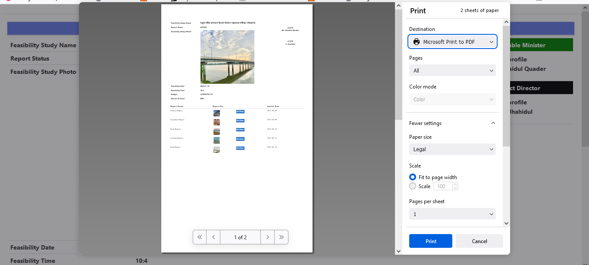

Figure 4.1.2.2: Single feasibility study report Print functionality

### Update Feasibility Study Data form

If click on the edit button then the updated feasibility study input form will appear which is like the below scenario. User can update & delete data as per as user required.

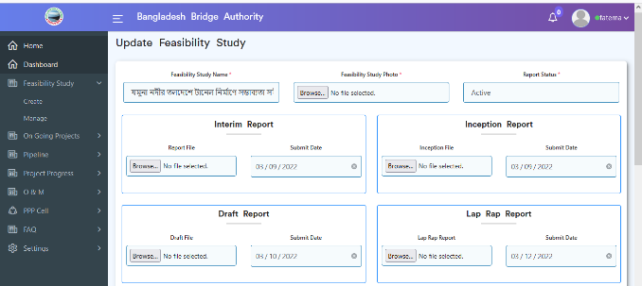

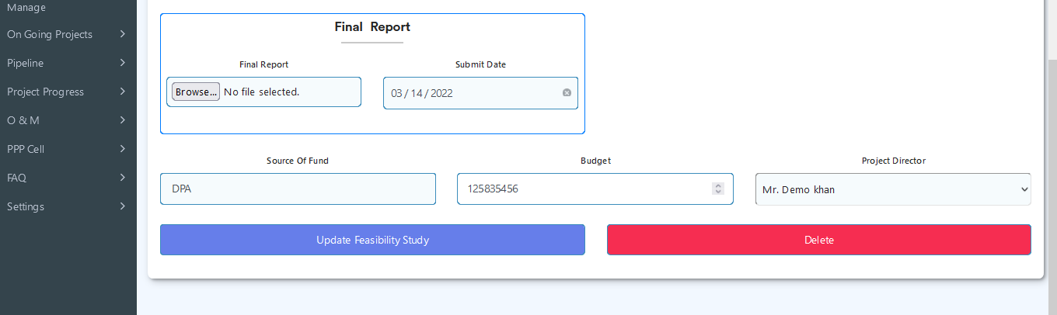

Figure 4.1.2.3: Update feasibility study data form

## 4.2: On Going Projects Overview

**Overview of On Going Project**

Click on the On Going Projects after that there will appear two sub menus and they are Create and Manage.

### 4.2.1:Create(On Going Project) Add new Construction Input Form

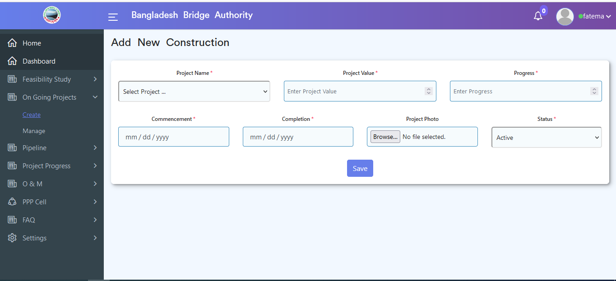

Figure 4.2.1: add new construction Input form

### 4.2.2: Manage (On Going Project) View all Construction Data

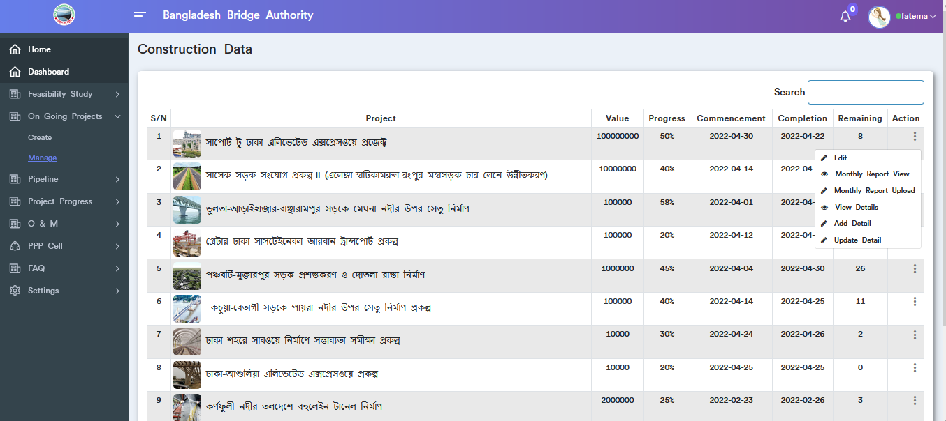

Figure 4.2.2: view all construction data

### Update Construction data:

Click on the dotted actions button then choose edit option after that it will redirect to update construction page. User can update input field data & can delete also.

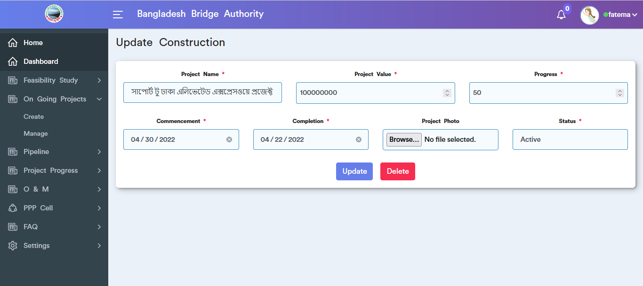

Figure 4.2.2.1: Update construction data

### Monthly Report view:

Click on the dotted actions button then choose Monthly report view option after that it will redirect to monthly report view page. User can update input field data as user required.

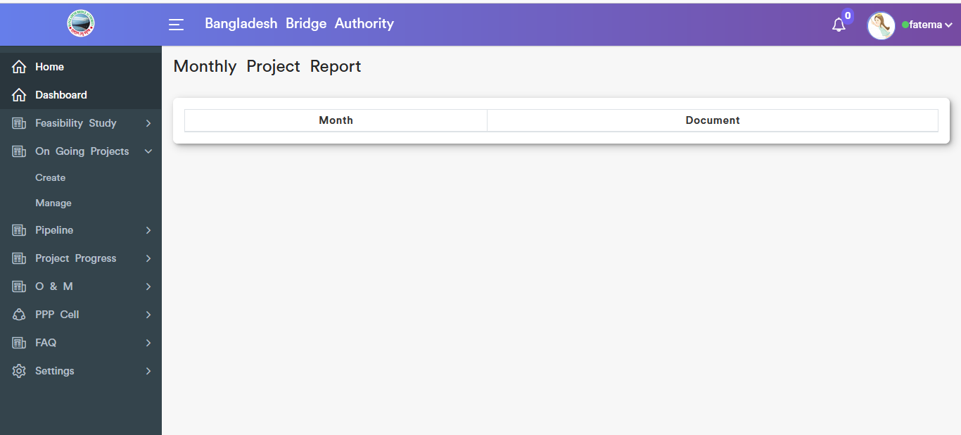

Figure 4.2.2.2: Monthly report view

### Monthly Project Report upload:

Click on the dotted actions button then choose Monthly report upload option after that it will redirect to monthly project report upload input form page. User must fill in the required fields with appropriate values.

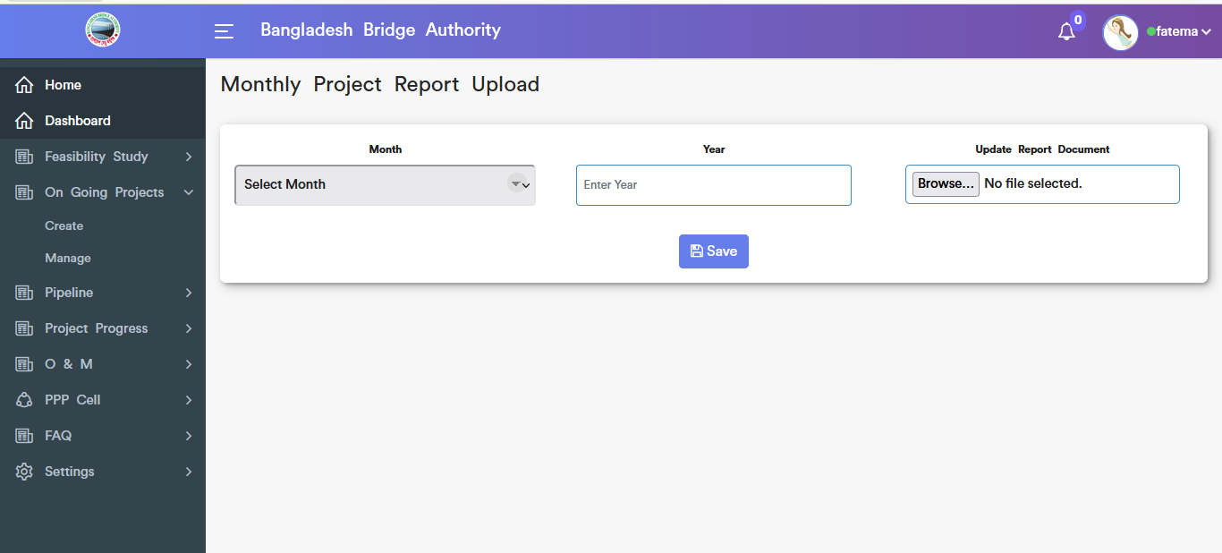

Figure 4.2.2.3: monthly project report upload form

### Single Constructions data view details:

Click on the dotted actions button then choose view details option after that it will redirect to single construction view details page. User must fill in the required fields with appropriate values.

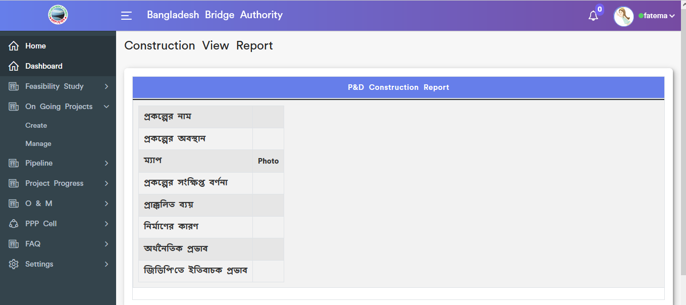

Figure 4.2.2.4: single construction data view details

### Add details:

Click on the dotted actions button then choose add details option after that it will redirect to add details input form page. User must fill in the required fields with appropriate values.

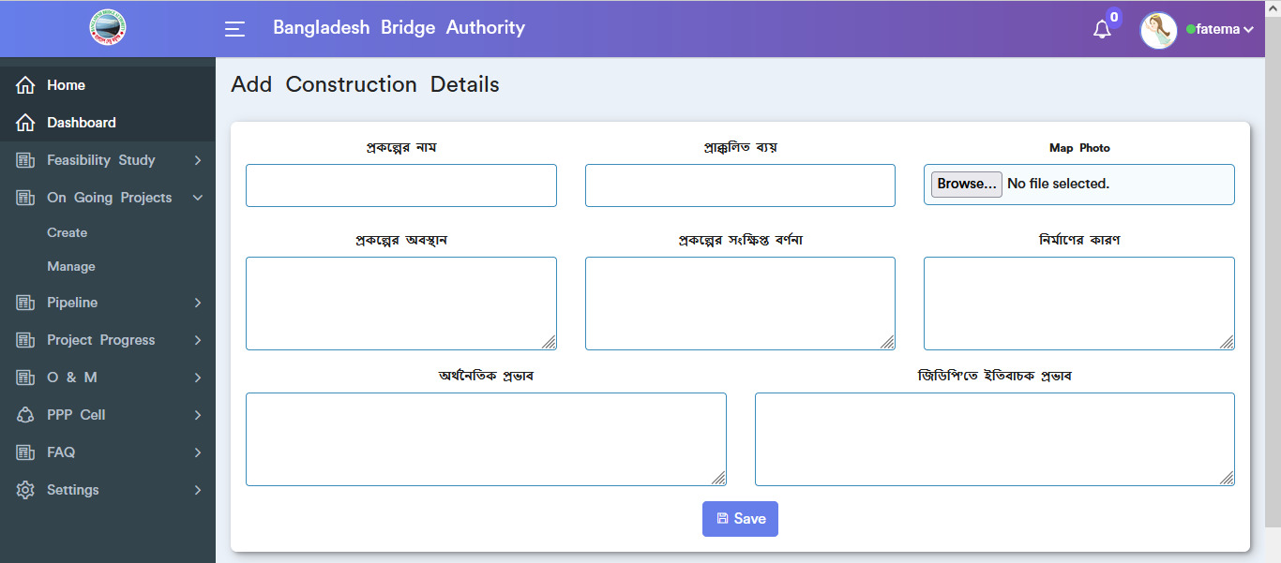

Figure 4.2.2.5: Add details input form

### Update details:

Click on the dotted actions button then choose update details option after that it will redirect to update details form page. User can update data as user required.

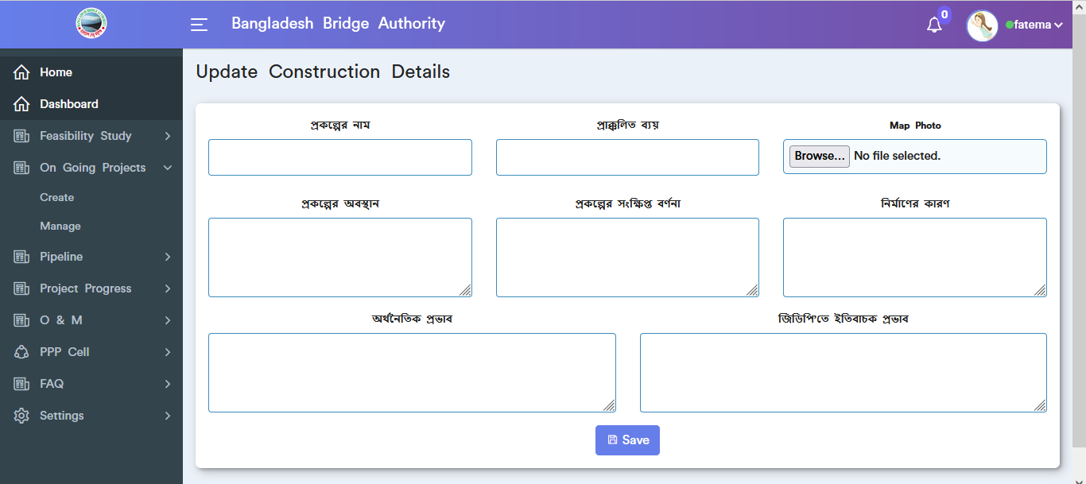

Figure 4.2.2.6: update construction details input form

## 4.3: Pipeline Overview

**Overview of Pipeline**

Click on the Pipeline after that there will appear two sub menus and they are Create and Manage .

### 4.3.1: Create (Pipeline) Add New Pipeline Input Form

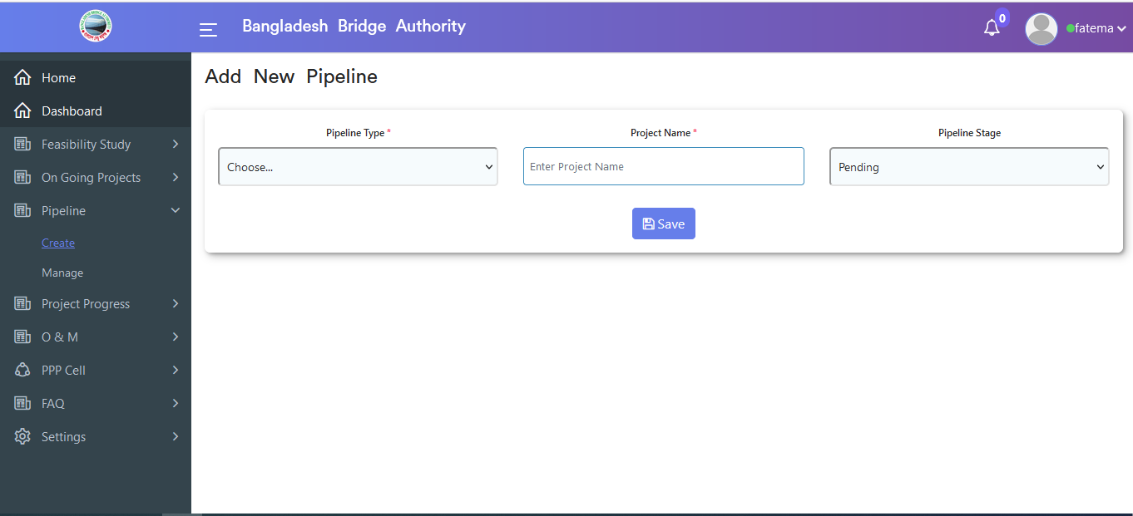

Figure 4.3.1: Add new pipeline Input form

### 4.3.2: Manage (Pipeline) View of Pipeline Data

.

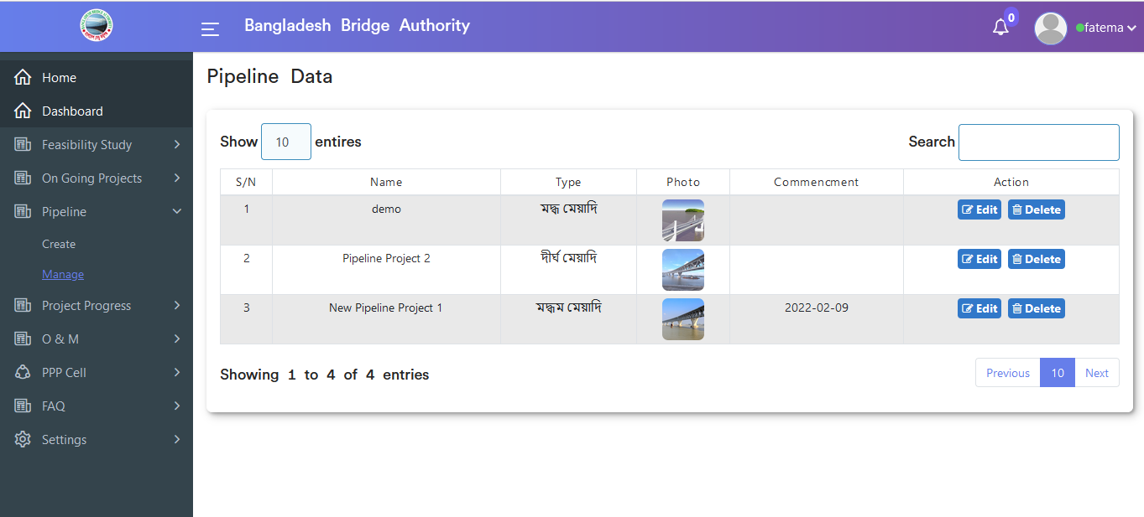 Figure 4.3.2: View Pipeline data

### Pipeline Data Edit

If click on the edit button then the update pipeline input form will appear which is like the below scenario. User can update data as user required.

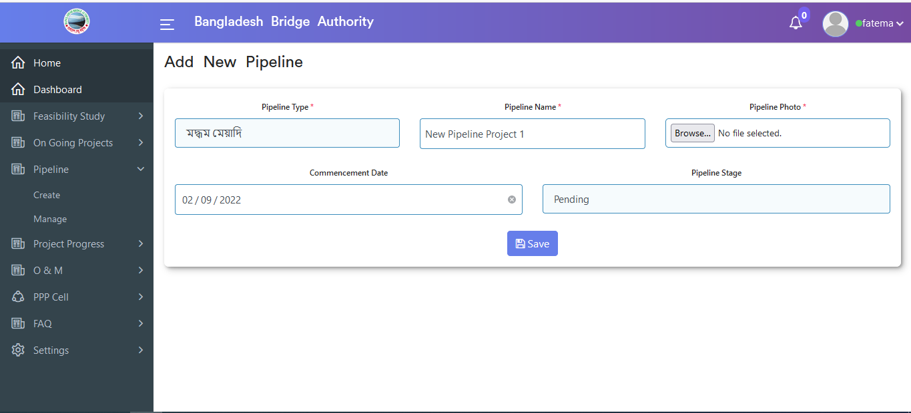

Figure 4.3.2.1:Pipeline data edit functionality

### Pipeline data delete functionality

If click on the delete button then looks like a pop-up modal will appear. If click ok on the pop-up modal then data will be deleted.

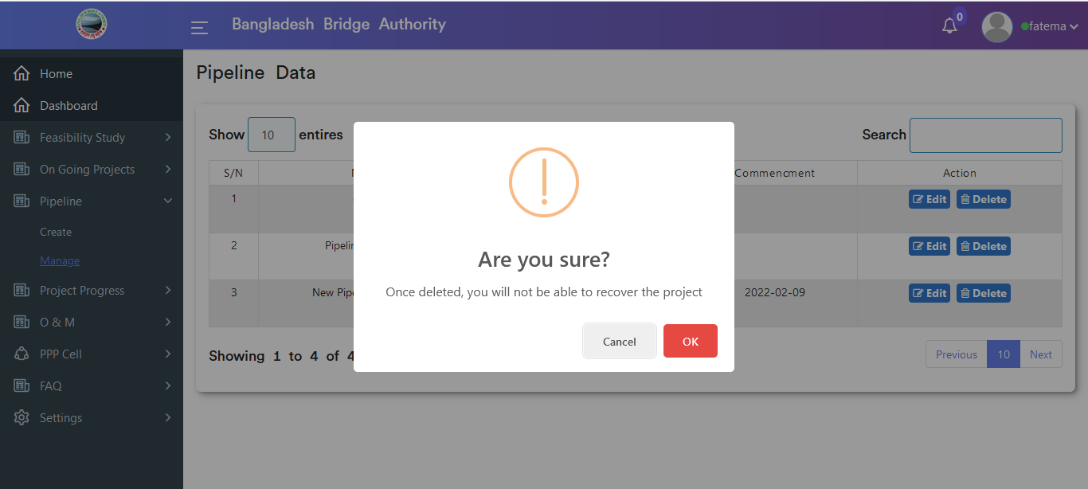

Figure 4.3.2.2:pipeline data delete functionality

## 4.4: Project Progress Overview

**Overview of Project Progress**

Click on the Project Progress after that there will appear three sub-menus and they are Create ,Manage and Photo Gallery .

### 4.4.1: Create (Project Progress) Add Construction of new projects & Add Details of project progress Input Form

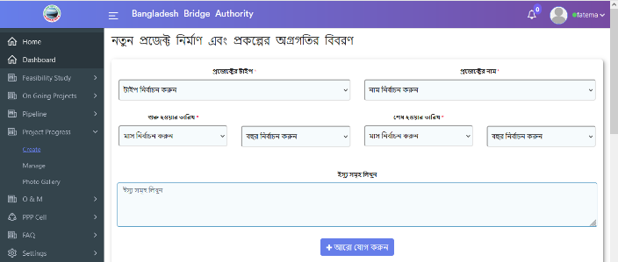

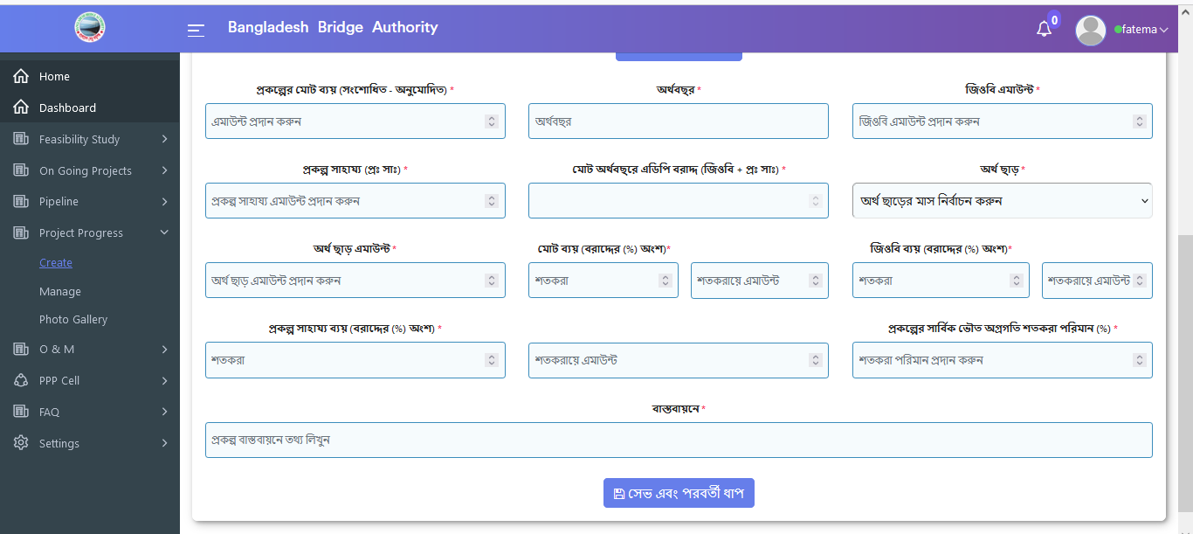

Figure 4.4.1: add construction of new project & Add details of project progress Input form

### 4.4.2: Manage (Project Progress) View Of Project Data

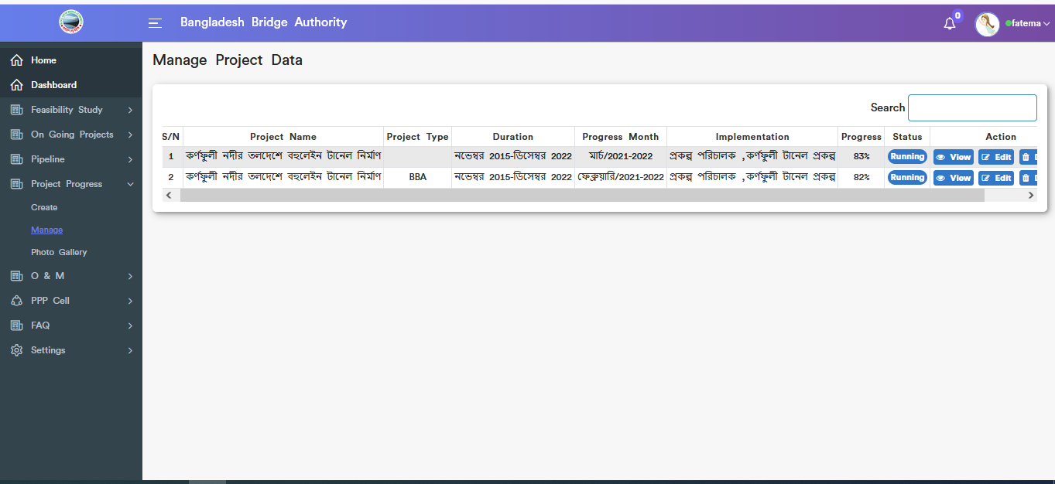

Figure 4.4.2: view project data

### View Single Construction Details

Click on the view button then it will redirect to single construction details page which is looks like below scenario.

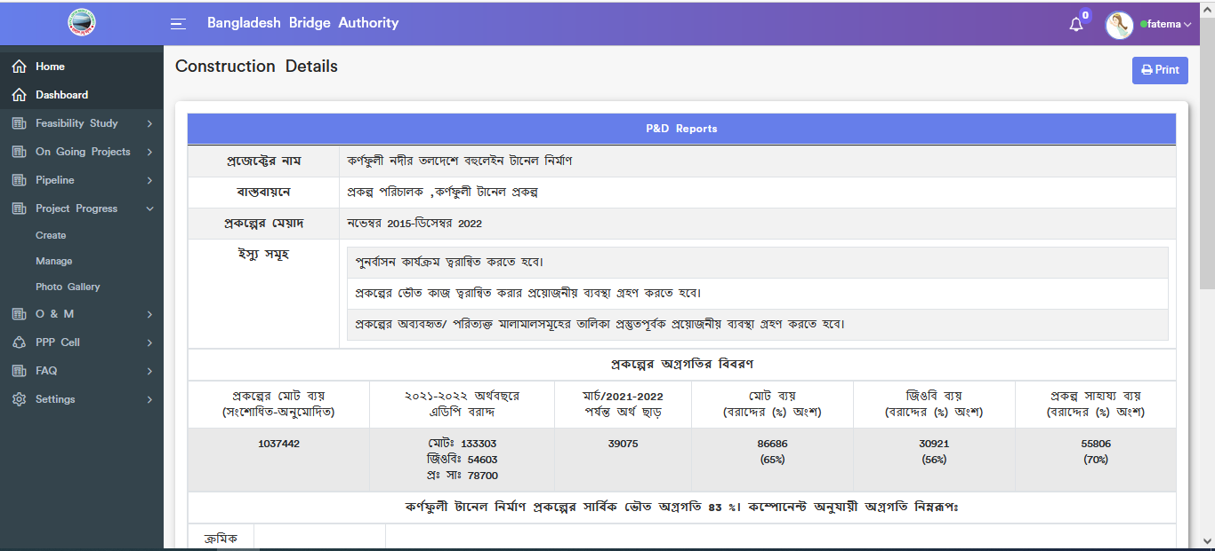

Figure 4.4.2.1: View single construction details

### View Single Construction Details Print

If click on the print button then looks like printing functionality will appear.

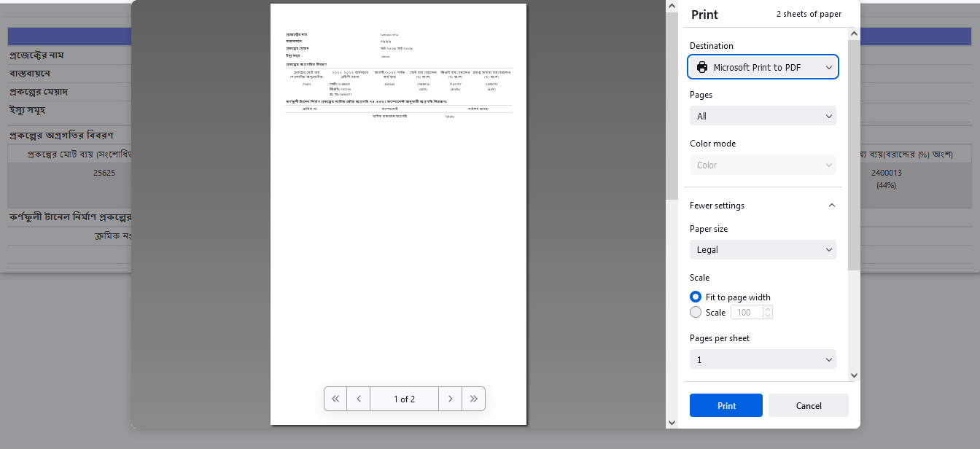 Figure 4.4.2.2: view single construction details print

### New Project & Details of the project progress Edit functionality

If click on the edit button then update the construction of the new project and details of the project progress update input form will appear which is like the below scenario. User can change data as user required.

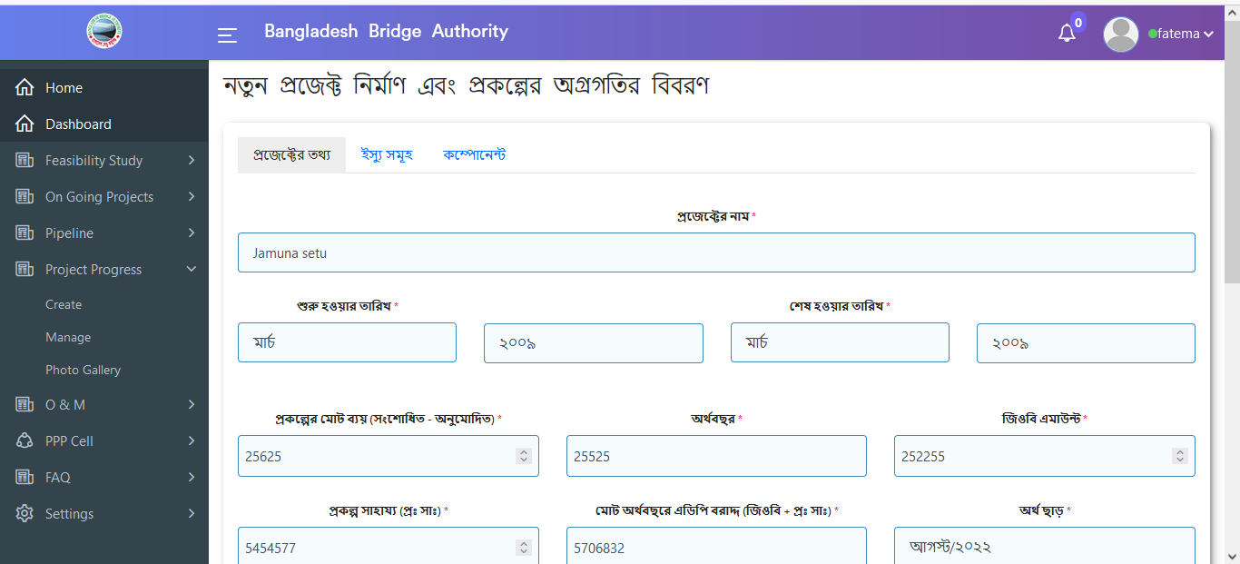

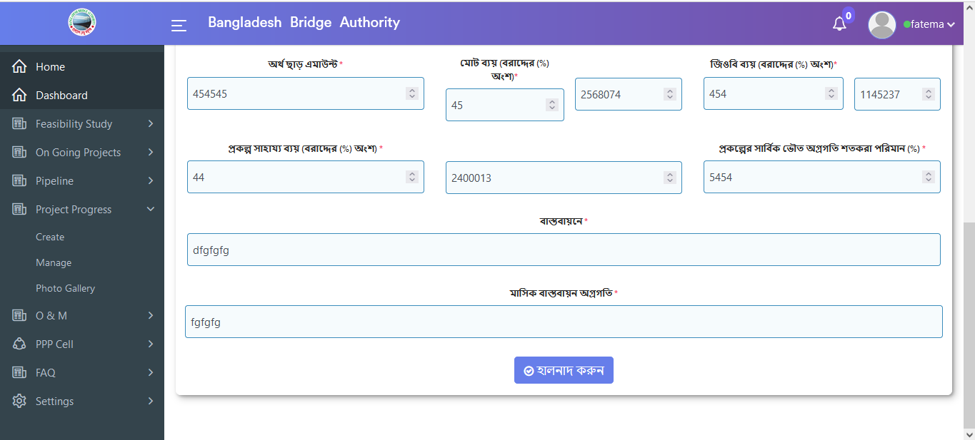

Figure 4.4.2.3: new project & details of the project progress edit functionality(Project info update form)

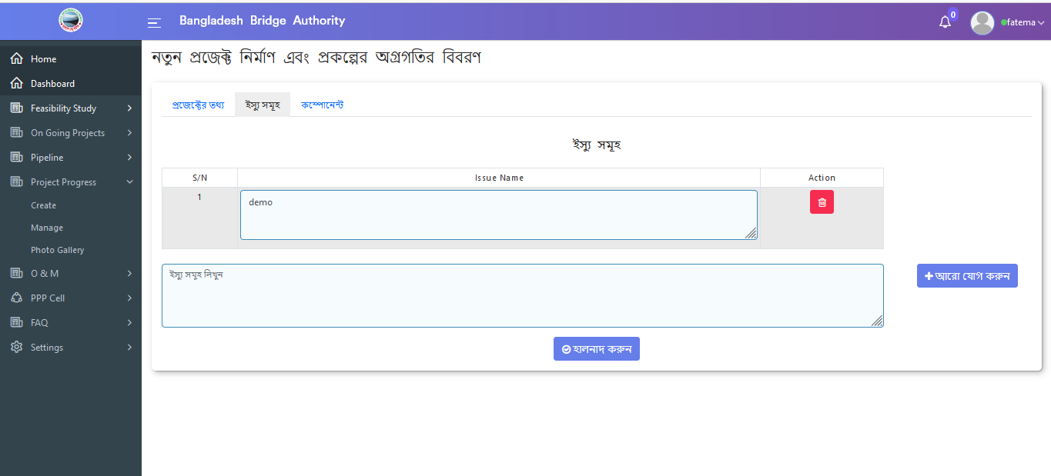

Figure 4.4.2.4: new project & details of the project progress edit functionality(Issues info update form)

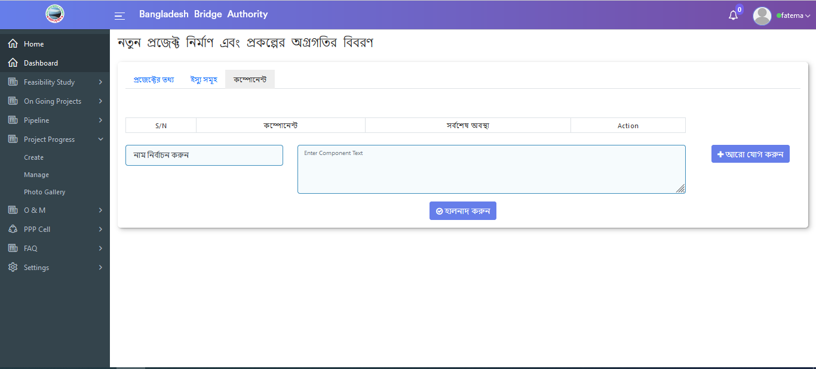

Figure 4.4.2.5: new project & details of the project progress edit functionality(Component update form)

### 4.4.3: Photo Gallery (Project Progress) View Photo Gallery Data

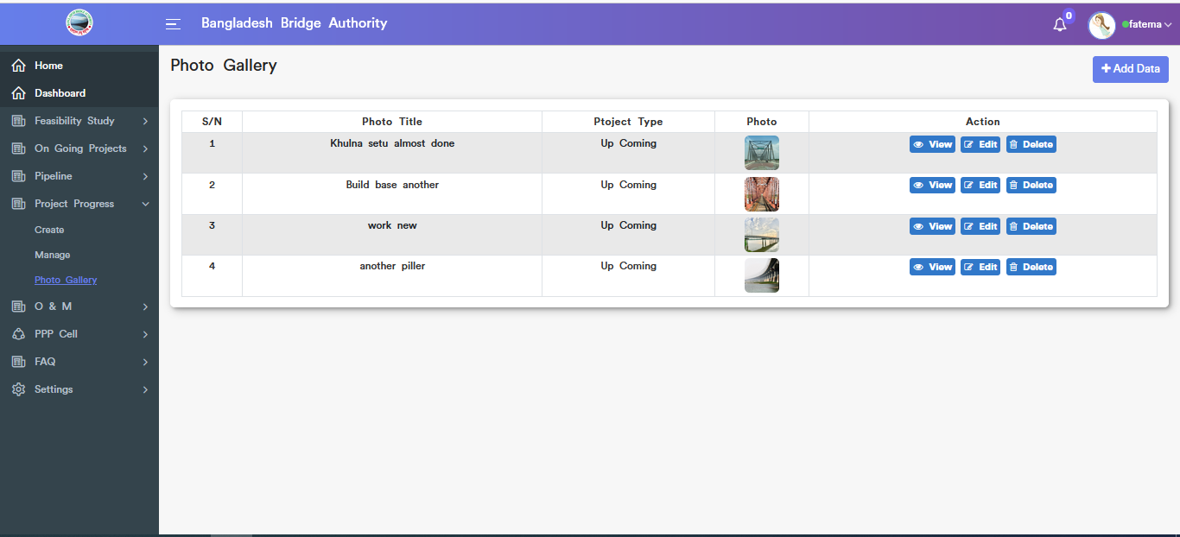

Figure 4.4.3: view Photo gallery data

#### Photo Add Data input form

Click on add data button after that looks like the below add input form will appear. User must fill in the required input fields with appropriate values to store photo gallery data in the database.

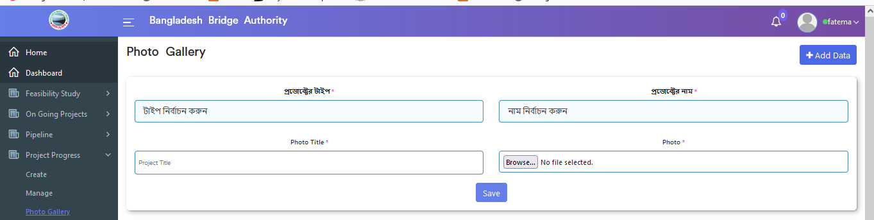

Figure 4.4.3.1: photo Add data input form

#### View of a single gallery data

Click on the view button then it will redirect to single photo gallery page.

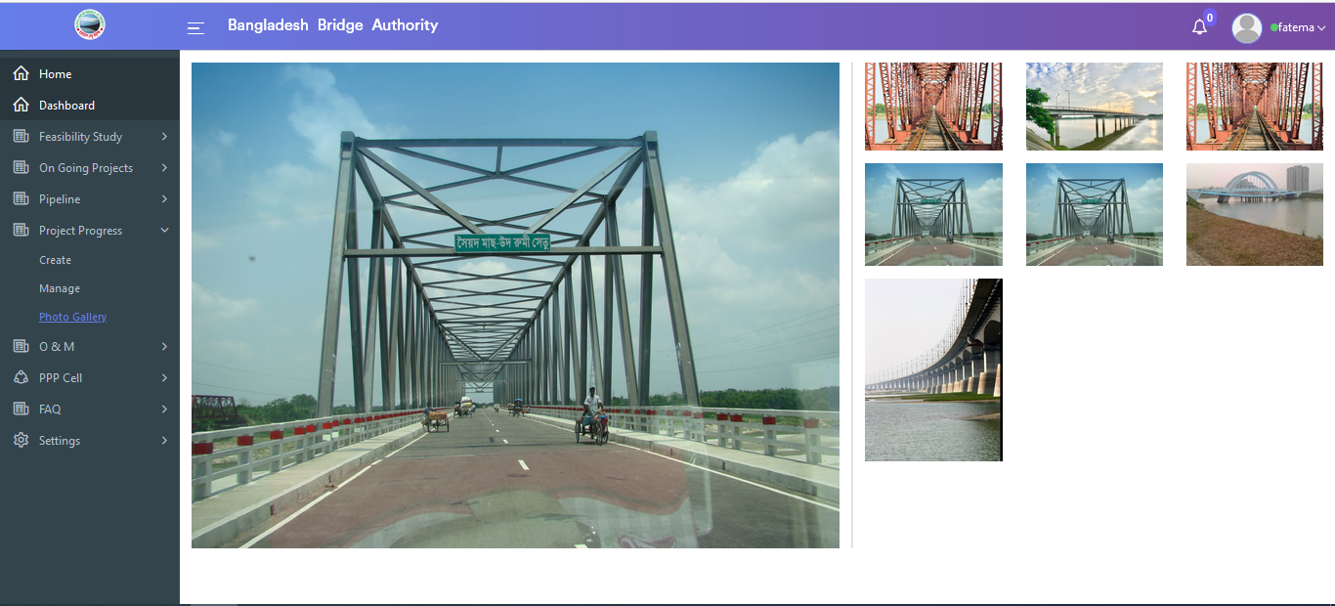

Figure 4.4.3.2:View single gallery data

### Edit Photo Gallery Data

Click on the edit button then the Update gallery data input form will appear which is like the below scenario .User can update input field data as user required.

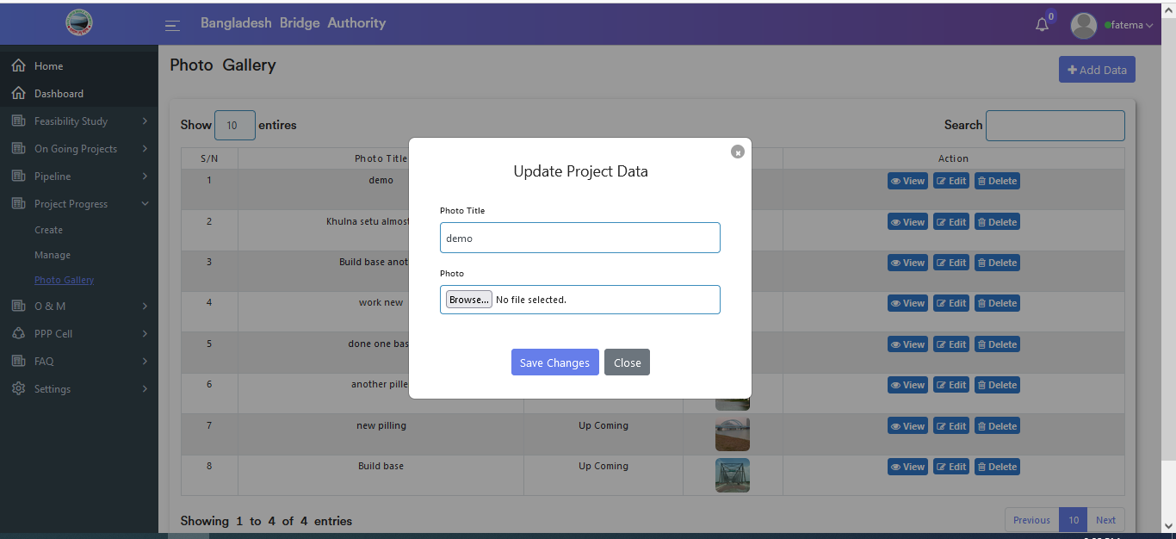

Figure 4.4.3-3:Edit photo Gallery Data

#### Delete Gallery Data

Click on the delete button then looks like a pop-up modal will appear. If click ok on the pop-up modal then data will be deleted.

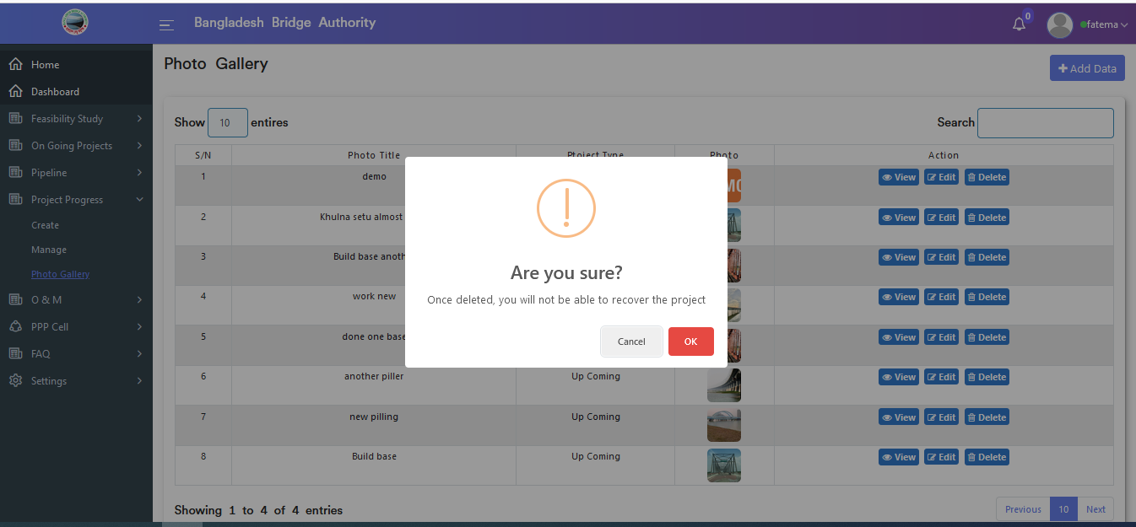

Figure 4.4.3-4: delete photo gallery Data

## 4.5: O & M (Operations And Maintenance) Overview

**Overview of Operations & Maintenance**

Click on the O & M after that there will appear two sub-menus and they are Create and Manage .

### 4.5.1: Create (O & M) Add New Operations & Maintenance Input Form

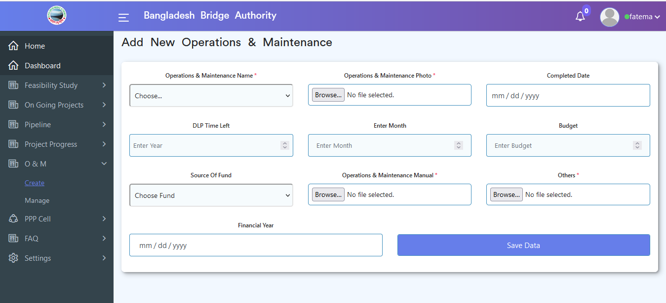

Figure 4.5.1: add new operations and maintenance Input form

### 4.5.2: Manage (O & M) View Operations & Maintenance Data

.

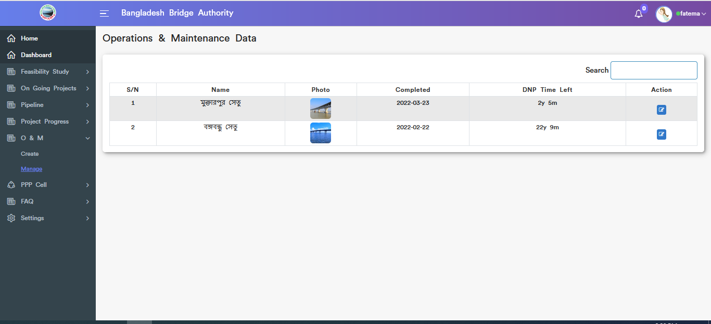

Figure 4.5.2: View Operations & Maintenance Data

### Update Operations & Maintenance Data

Click on the edit button then update operations & maintenance data input form will appear which is like the below scenario. User can update & delete data as user required.

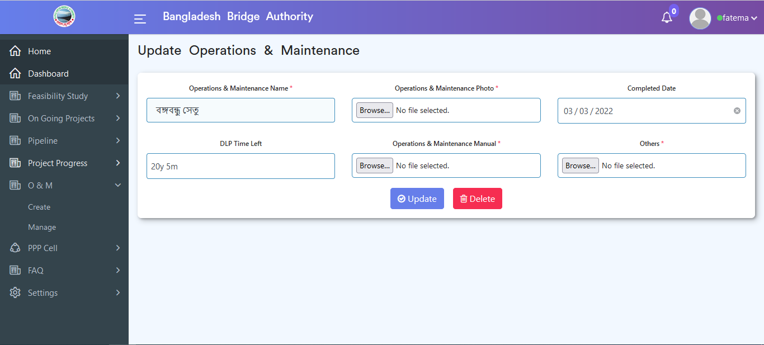

Figure 4.5.2: update Operations & Maintenance Data

## 4.6: PPP Cell Overview

**Overview of PPP Cell**

Click on the PPP Cell after that there will appear three sub-menus and they are **About PPP Cell** , **Upcoming PPP Project** and **On Going PPP Project**. Upcoming PPP Project sub-menu has also two sub menus and they are **create** sub-sub-menu and **manage** sub-sub-menu.On Going PPP Project also has two sub-menu they are **create** sub sub-menu and **manage** sub sub-menu.

### 4.6.1: About PPP Cell(PPP Cell) View about ppp cell

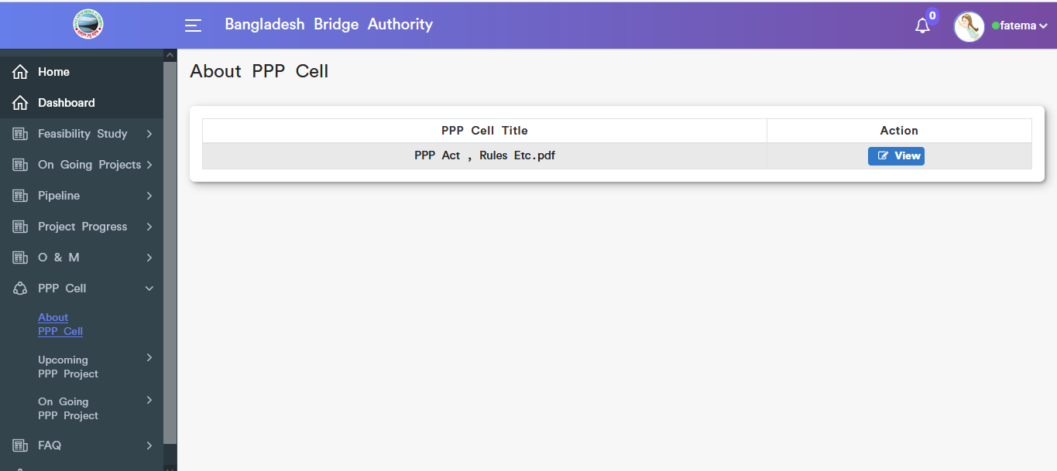

Figure 4.6.1: view about ppp cell data

#### Download About ppp cell data:

Click on the view button after that a pop-up modal will display for download the pdf.

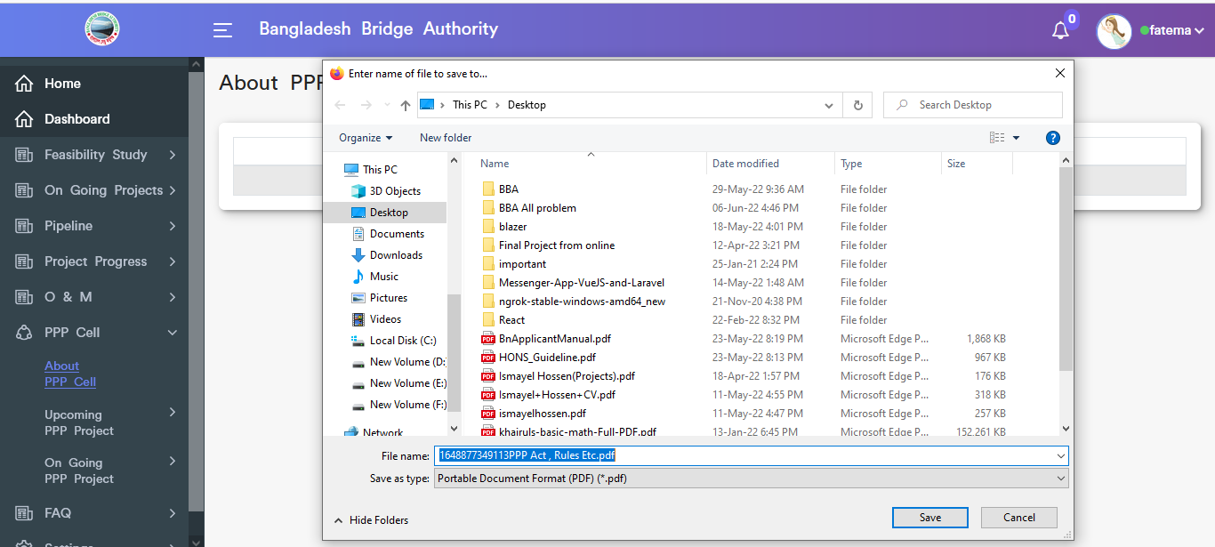

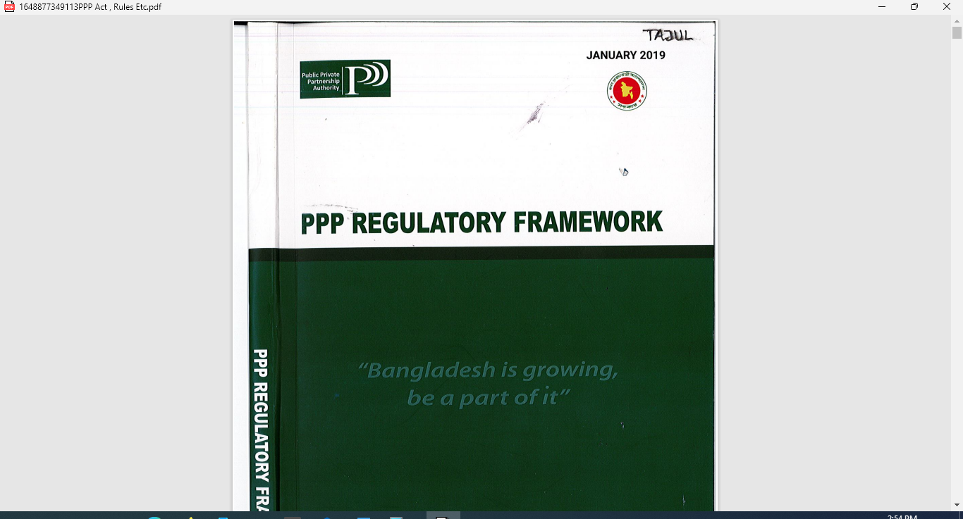

Figure 4.6.1.1: download about ppp cell data

### 4.6.2.1: Create<-Upcoming ppp project<-(PPP Cell) Upcoming ppp project create input from

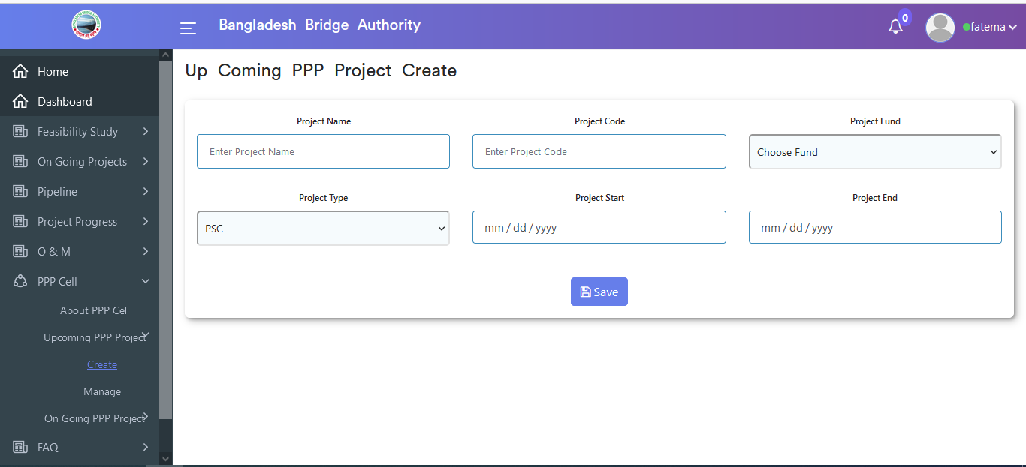

Figure 4.6.2.1: View up coming ppp project create input form

### 4.6.2.2: Manage<-Upcoming ppp project<-(PPP Cell) View upcoming all ppp project data

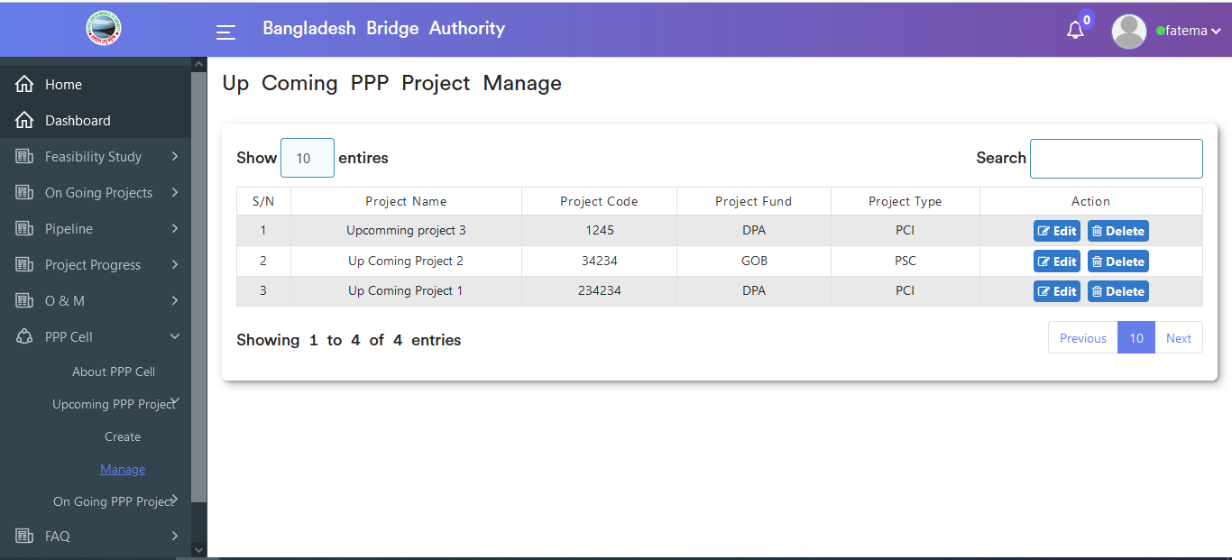

Figure 4.6.2.2: view upcoming all ppp project data

#### Upcoming ppp project data Search

User can search data by project name from the upcoming ppp project data table.

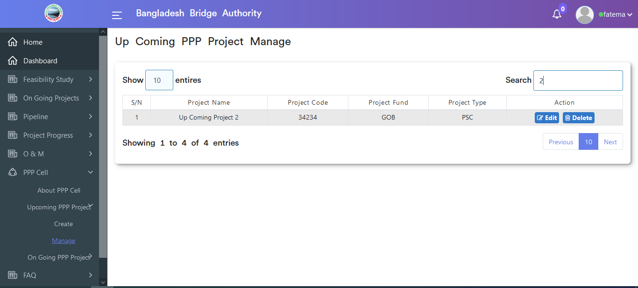

Figure 4.6.2.2.1: upcoming project data search

#### Update upcoming PPP project data

Click on the edit button then update upcoming project input form will appear which is like the below scenario. User has can update data as user required.

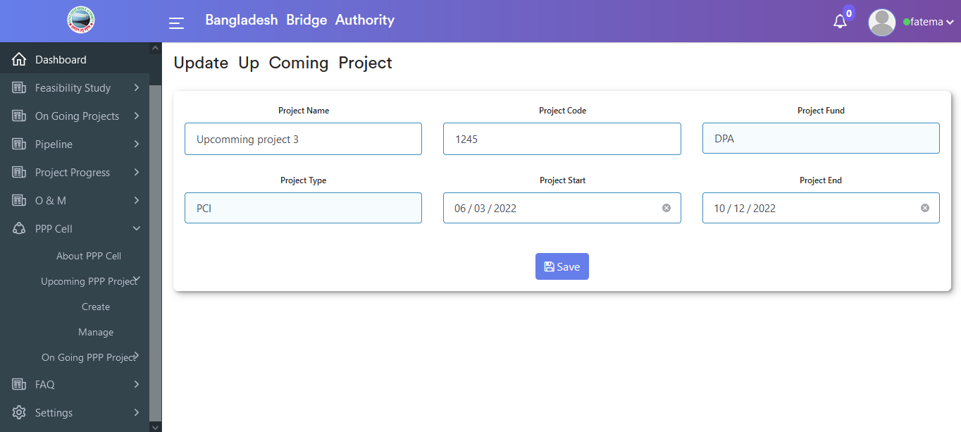

Figure 4.6.2.2.2: update upcoming ppp project form data

#### Upcoming ppp project data Delete

Click on the delete button then looks like a pop-up modal will appear. If click ok on the pop-up modal then data will be deleted.

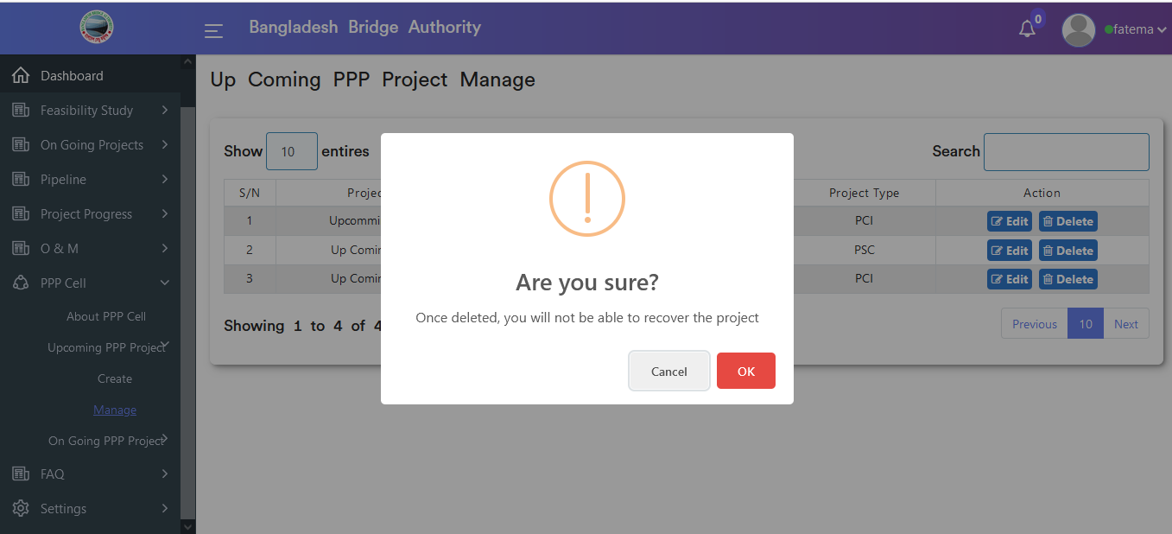

Figure 4.6.2.2.3:upcoming ppp project data delete

### 4.6.3.1: Create-Ongoing ppp project-(PPP Cell) Ongoing ppp project create input from

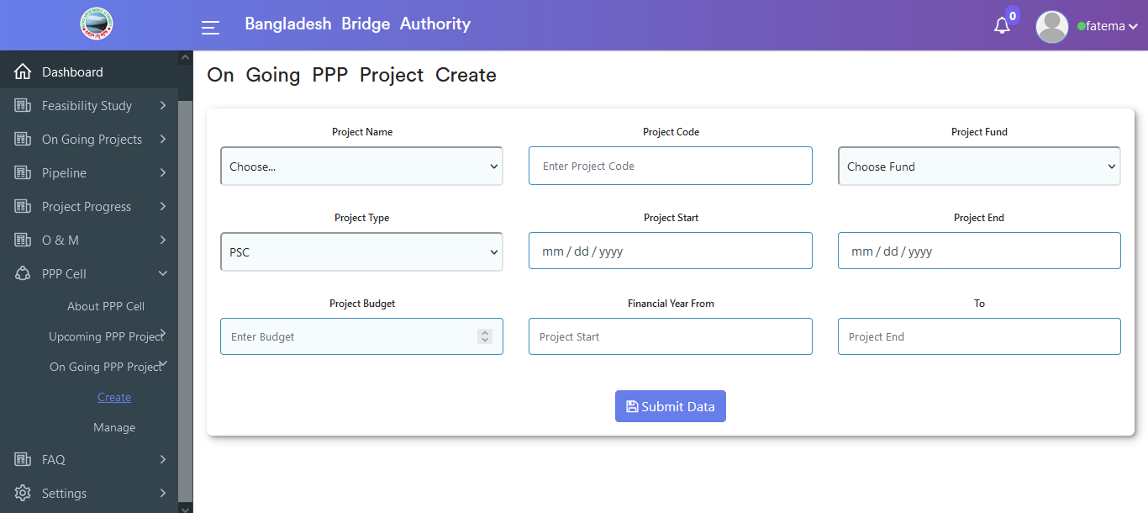

Figure 4.6.3.1: ongoing ppp project create an input form

### 4.6.3.2: Manage-Ongoing ppp project-(PPP Cell) View of ongoing ppp project data

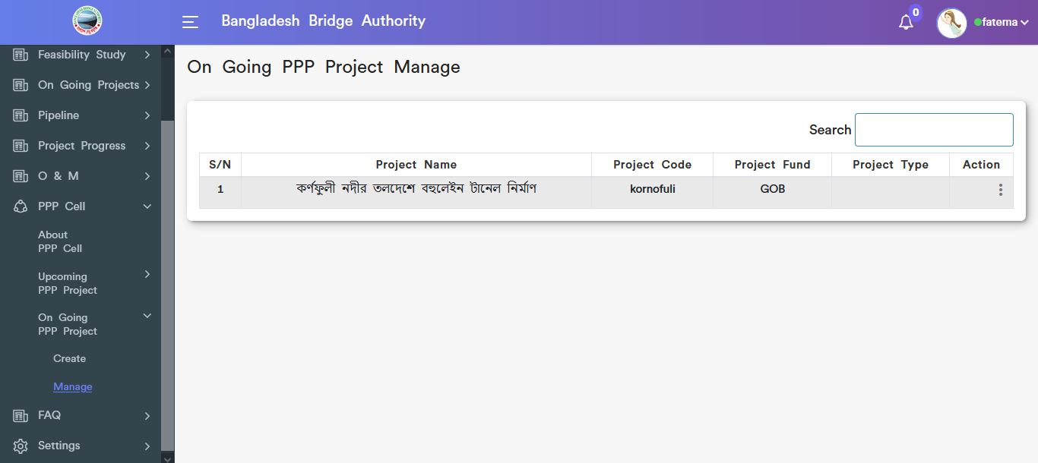

Figure 4.6.3.2: view ongoing ppp project data

### Ongoing ppp project data Search

User can search data by project name from the ongoing ppp project data table.

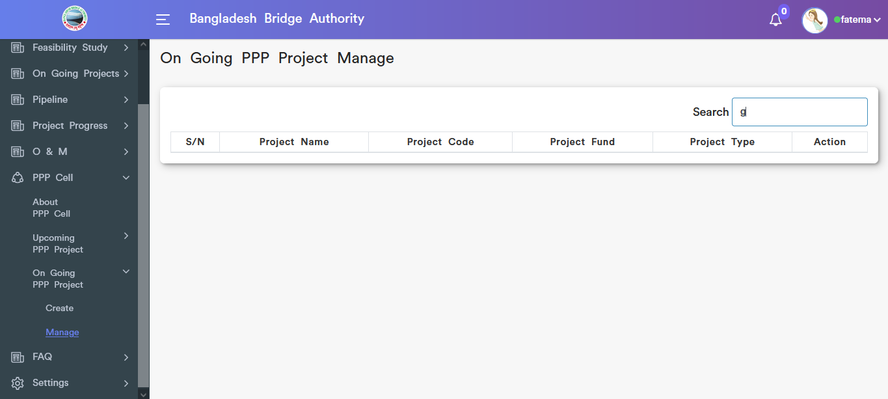

Figure 4.6.3.2.1: ongoing ppp project data search

### Update ongoing ppp project data input form

Click on the dotted button then choose edit options after that update ongoing project input form will appear which is like the below scenario. User can update data as user required.

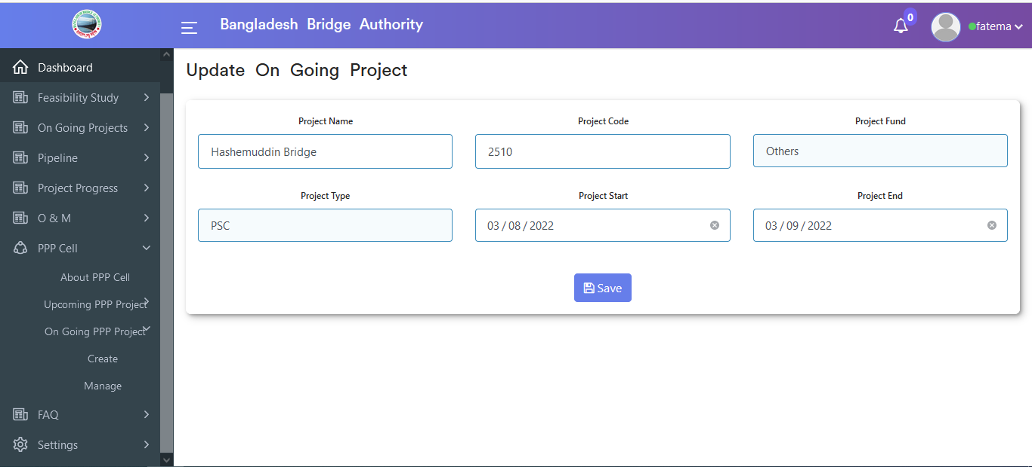

Figure 4.6.3.2.2: update ongoing ppp project form

### Ongoing ppp project data Delete

Click on the delete button then looks like pop-up modal will appear. If click ok on the pop-up modal then data will be deleted.

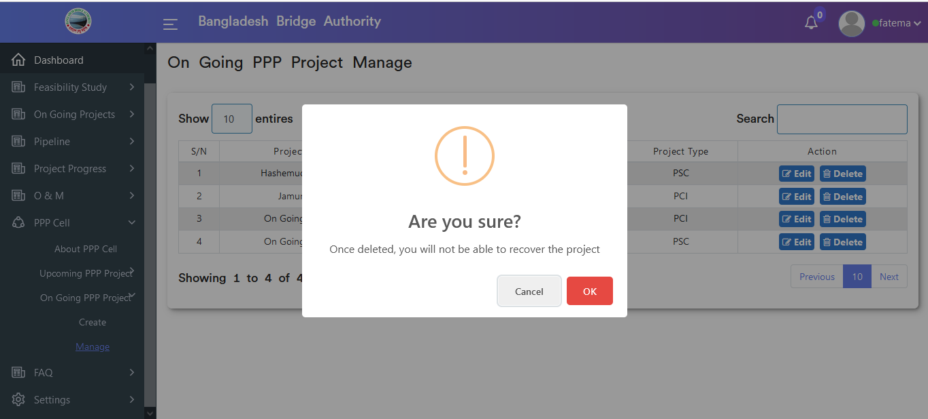

Figure 4.6.3.2.3: ongoing ppp project data delete

## 4.7: FAQ Overview

**Overview of FAQ**

Click on FAQ after that there will appear create sub-menu.

### 4.7.1: Create (FAQ) View of faq data

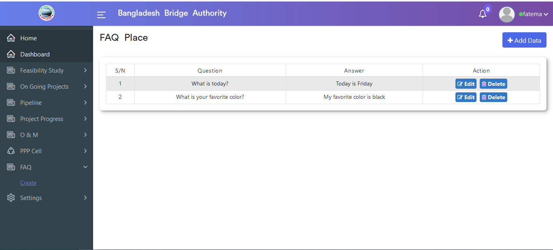

Figure 4.7.2: view faq all data

### Add Faq Data input form

Click on the Add data button after that Faq place input form will appear as like the below scenario .User must fill in the required input fields with appropriate values to store faq questions record in the database.

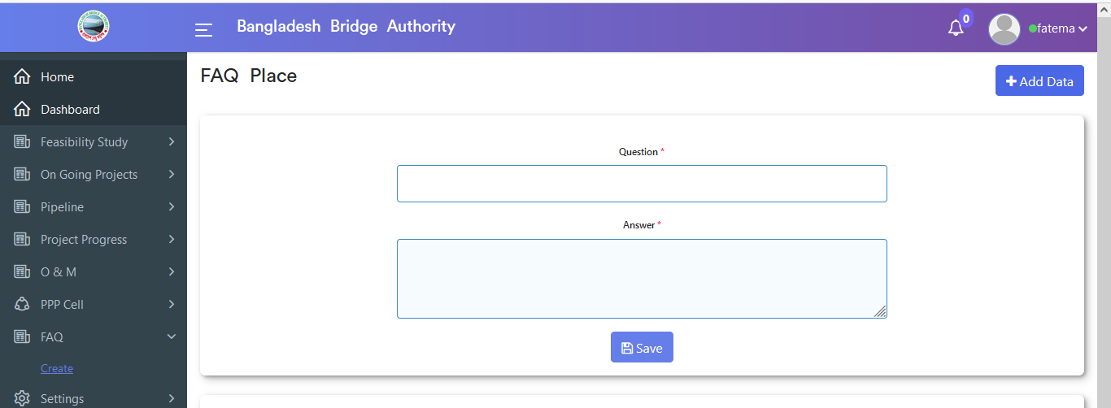

Figure 4.7.2: add data input form

### Edit FAQ data

Click on the edit button then pop-up modal input form will appear which is like the below scenario. User can update data as user required.

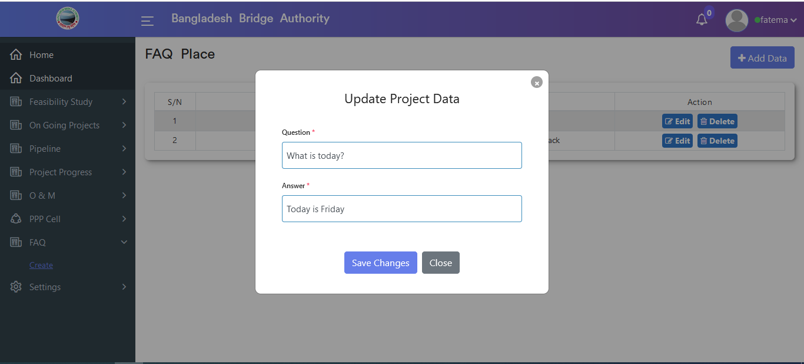

Figure 4.7.3: edit faq data

### Delete FAQ Data

Click on the delete button then looks like a pop-up modal will appear. If click ok on the pop-up modal then data will be deleted.

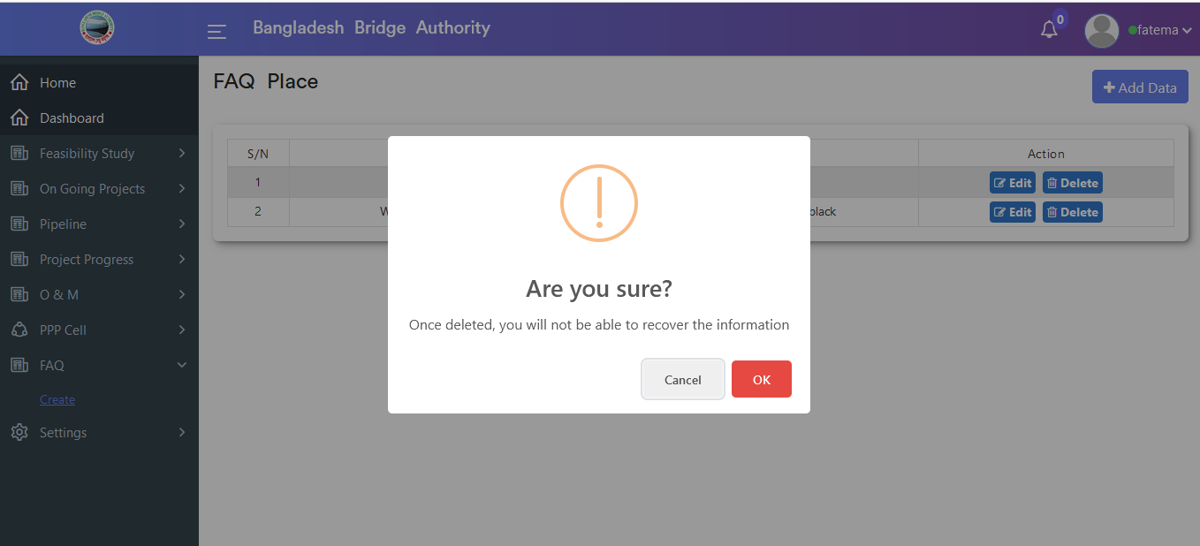

Figure 4.7.4: delete FAQ data

## 4.8: Settings Overview

**Overview of Settings**

Click on the settings menu after that there will appear three sub-menu & they are **FCP**, **Component Data** and **Project Data**

### 4.8.1.1: FCP(Settings) View fcp data

Click on the fcp(settings) sub-menu after that looks like scenario will appear if data is available in the database.

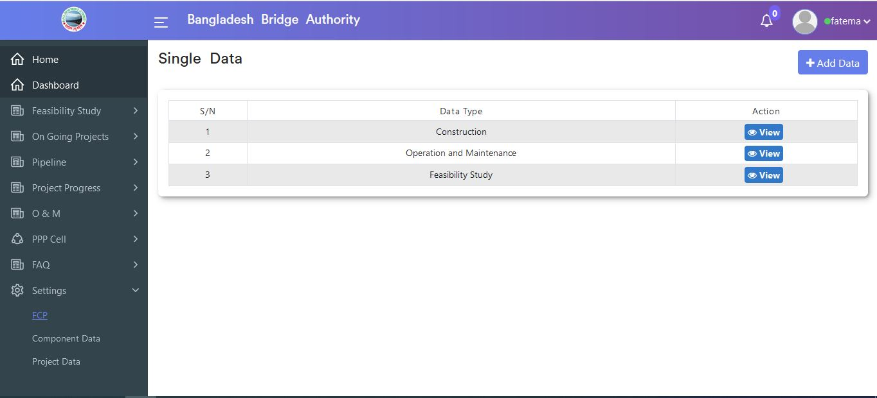

Figure 4.8.1.1: view fcp data

### FCP Add data input form

Click on the Add data button after that input form will appear as like below scenario . User must fill in the required input fields with appropriate values to store the fcp record in the database.

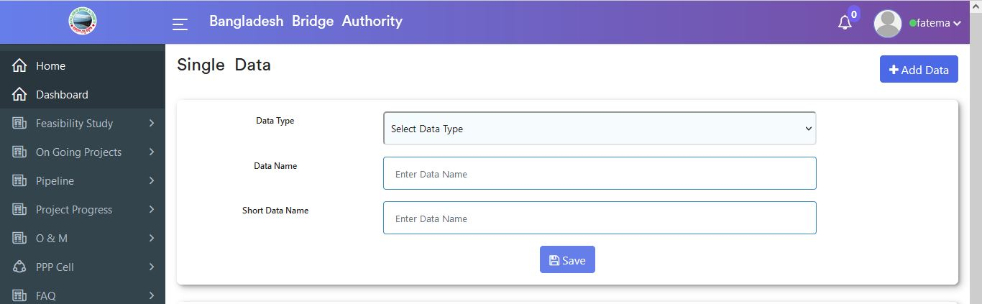

Figure 4.8.1.2: fcp Add data input form

### View FCP single data details

Click on the view button then looks like single data of FCP will appear.

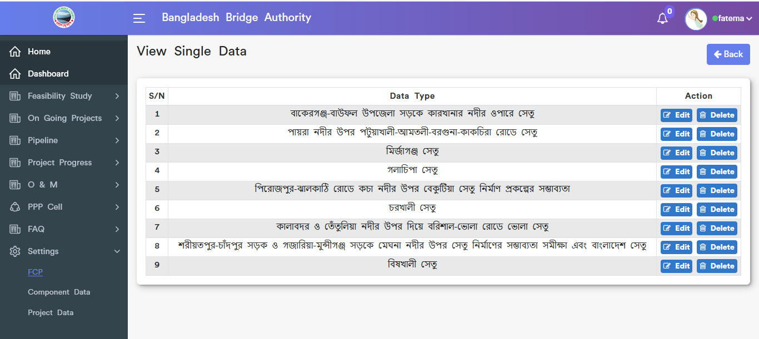

Figure 4.8.1.3: view fcp single data

### FCP single data edit

Click on the edit button then a pop-up modal input form will appear which is like the below scenario. User can update data as user required.

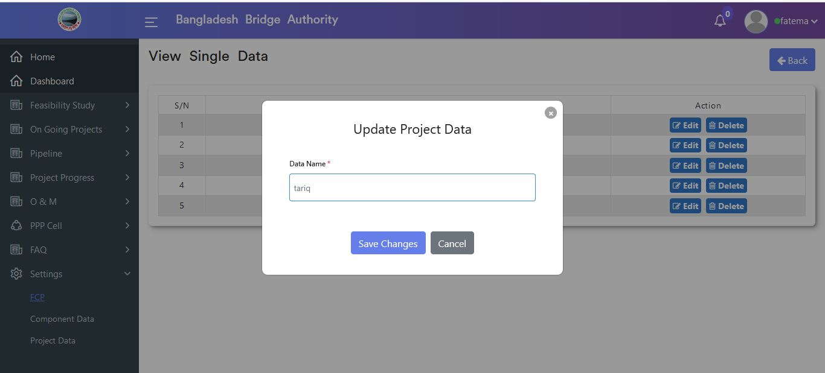

Figure 4.8.1.4: fcp single data edit

### fcp single data delete

Click on the delete button then looks like a pop-up modal will appear. If click ok on the pop-up modal then data will be deleted.

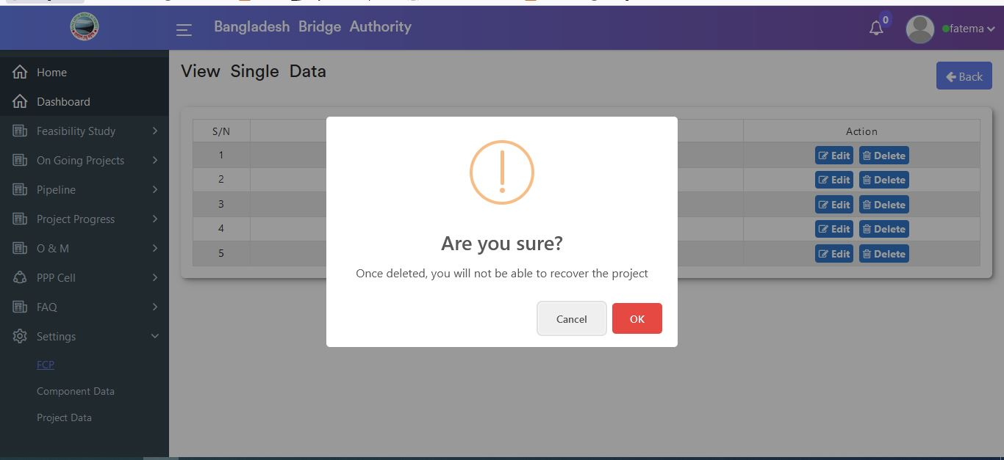

Figure 4.8.1.5: fcp single data delete

### 4.8.2.1: Component Data(Settings) Add data input form

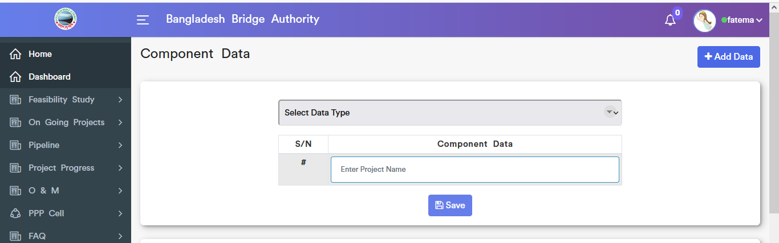

Figure 4.8.2.1: component add data input form

### View component and project data:

There are two types data in the component sections & they are Component data and project data

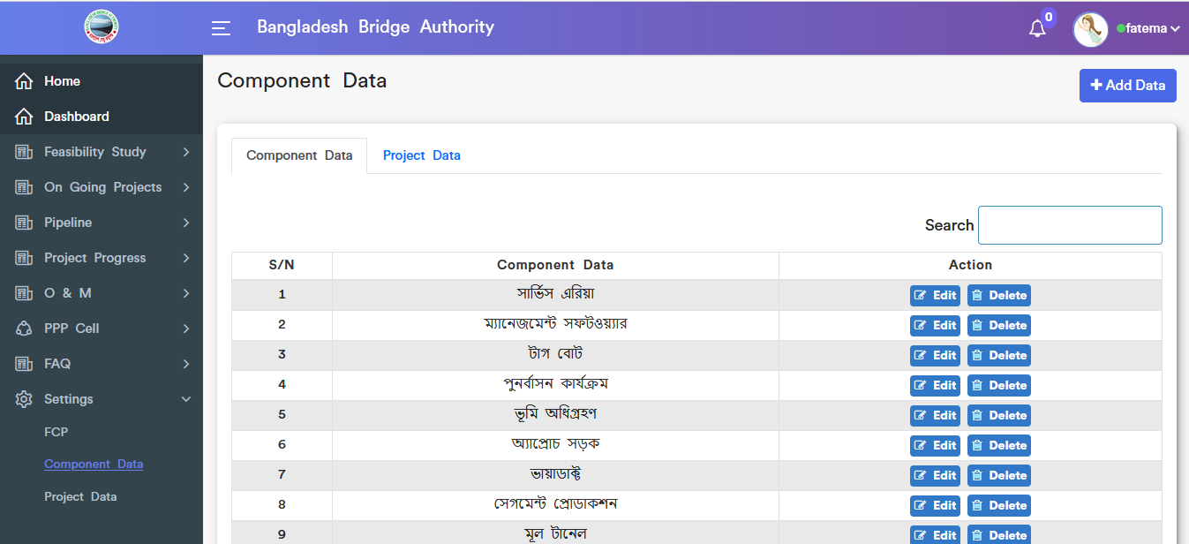

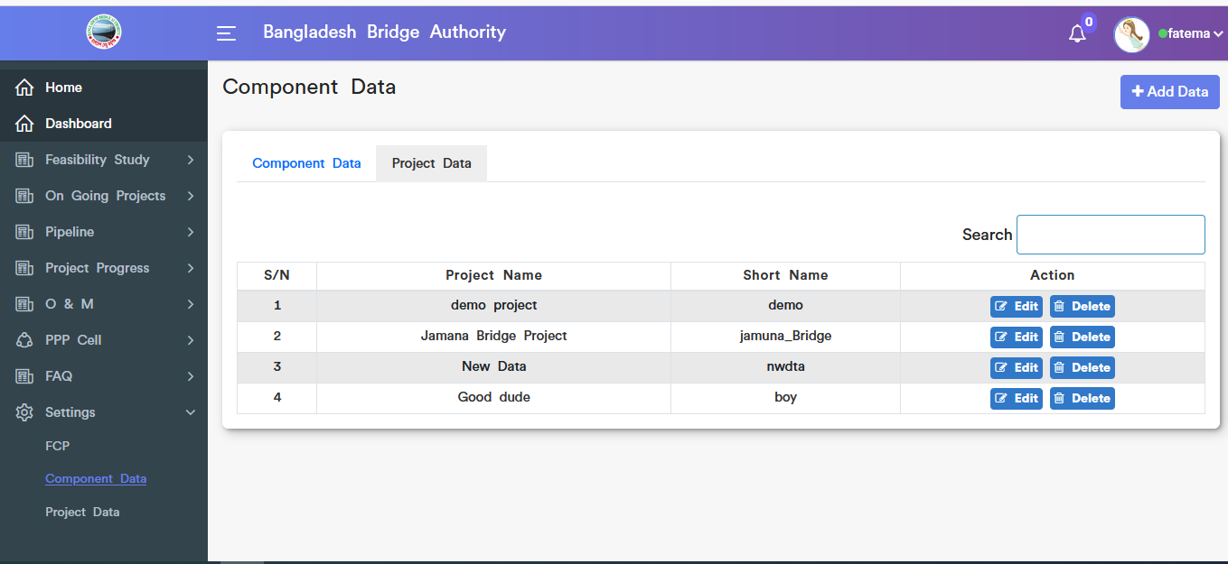

Figure 4.8.2.2: view component and project data

### Component data edit

Click on the edit button then pop-up modal input form will appear which is like the below scenario. User can update data as user required.

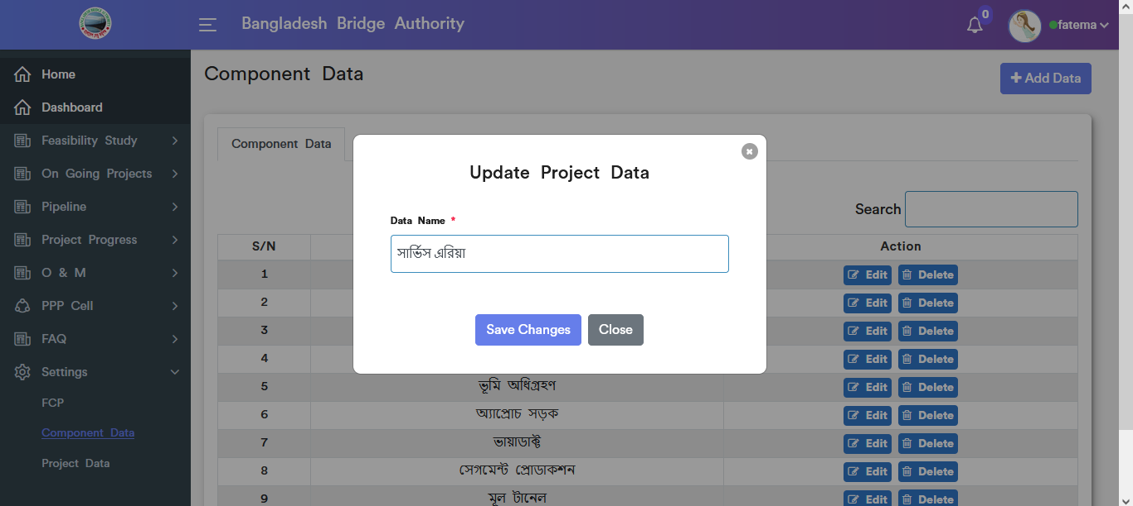

Figure 4.8.2.3: component data update

#### Component data delete

Click on the delete button then looks like a pop-up modal will appear. If click ok on the pop-up modal then data will be deleted.

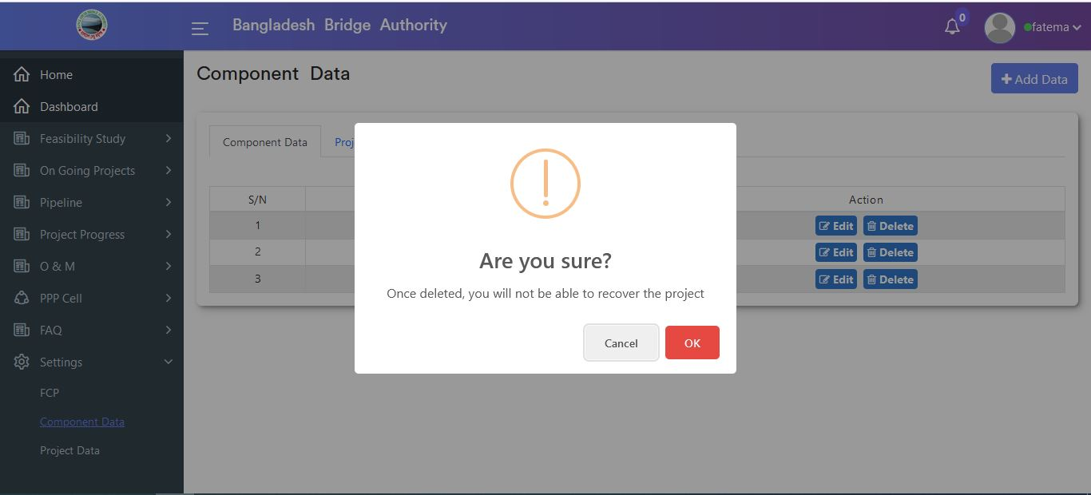

Figure 4.8.2.4: component data delete

### Project data Update form

Click on the edit button then pop-up modal input form will appear which is like the below scenario. User can update data as user required.

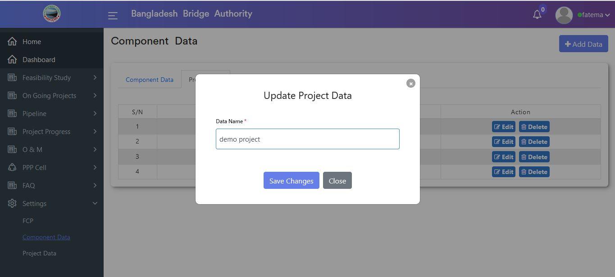

Figure 4.8.2.5: project data update form

### Project data delete

Click on the delete button then looks like a pop-up modal will appear. If click ok on the pop-up modal then data will be deleted.



Figure 4.8.2.6: project data delete

### 4.8.3.1: Project Data(Settings) Add project data input form

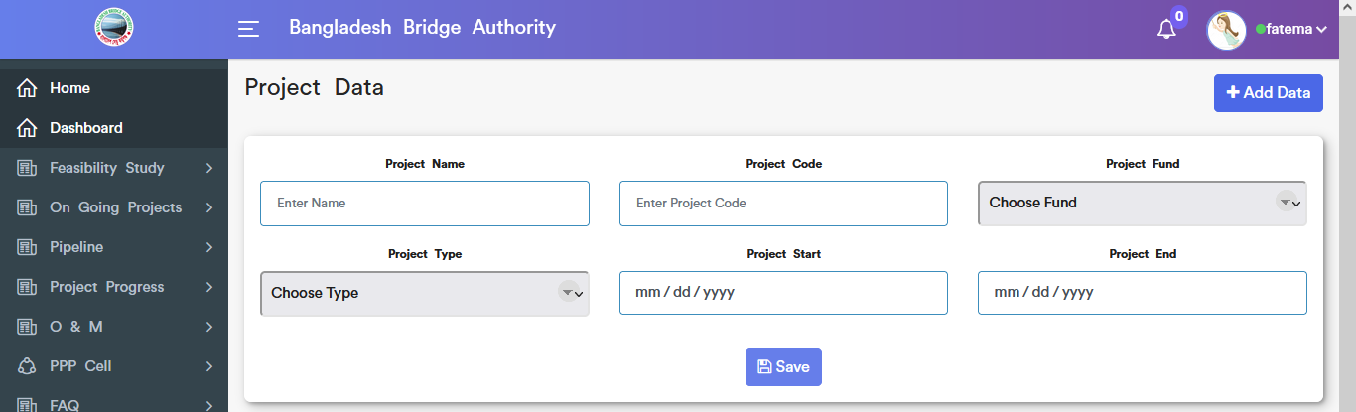

Figure 4.8.3.1: add project data input form

### Project data edit

Click on the edit button then pop-up modal input form will appear which is like the below scenario. User can update data as user required.

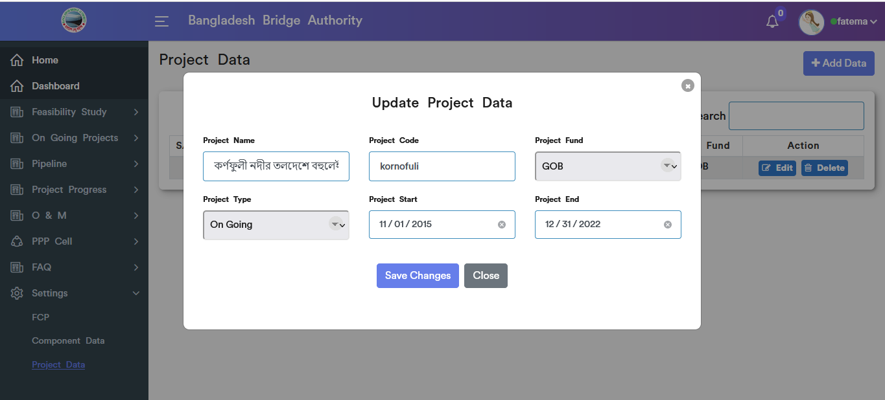

Figure 4.8.3.2: project data edit

### Project data delete

Click on the delete button then looks like a pop-up modal will appear. If click ok on the pop-up modal then data will be deleted.

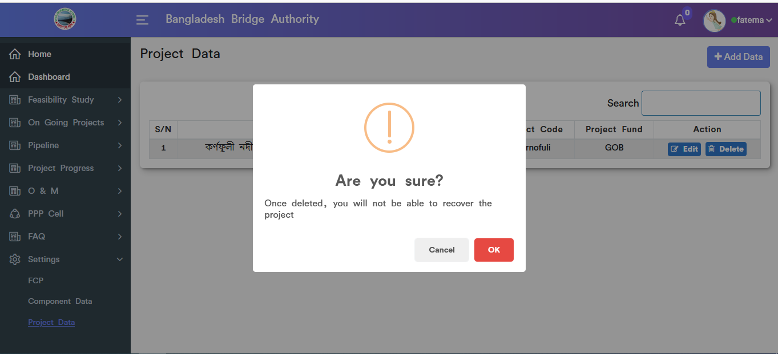

Figure 4.8.3.3: project data delete